# 

**Part1: Theoretical Understanding Of DL** **3**

Jason Lee (Princeton) 3

Part1: Representation Learning 4

Self-Supervised Representation Learning 7

Andrew Stolman 11

Why do Large Models Work? 16

Yasaman Bahri 18

**Part2: Scaling Deep Learning** **20**

Utility Bill ($) of DL Eric Xing (CMU) 20

TRENDS and CHALLENGES 21

How to Reduce Cost 23

Auto - Parallel a Model 24

Auto Schedule: How to schedule multiple Tasks 30

Auto Tune 34

Summary 37

A Common Framework 38

CODE (www.casl-project.ai) 40

Arun Kumar (Delusions Of DL) 41

Toward Building Responsbile Data Ecnonly (Dawn Song Berkeley) 43

Deepak Agarwal (Pinterest - Head of Core Engineering) 45

Pinterest 45

Deploying DL Models 47

Shared/Common Embeddings 48

Application Specifc Models 50

Engineering: 50

Deep Dive: Home Feed 51

Conclustion 53

**Part3: Fairness and Transparency of Deep Learning Model** **54**

James Zou (Stanford) 54

Challenge 1: Characterizing the data 58

Challenge 2: How do different data contribute to model behavior 60

Challenge 3: Leveraging human with AI Data 66

Interpreting Interpretability 72

Martin Wattenberg (Google/Harvard) 73

**Part4: Evaluating and Debugging Deep Learning Model** **74**

Besmira Nushi (Microsoft Research) 74

Myth: Uniform Model Accuracy/Perforamcne 75

Myth: Debugging ML model is only an issue for large models (1billion param) 82

An Integrated Tool set (WIP - months) 86

Myth: 86

Other aspects 89

Daniel Kang: Model and Label Assertion 90

Illusions of Network Embeddings 98

Aleksander Madry (MIT) 102

# 

# 

# Part1: Theoretical Understanding Of DL

## Jason Lee (Princeton)

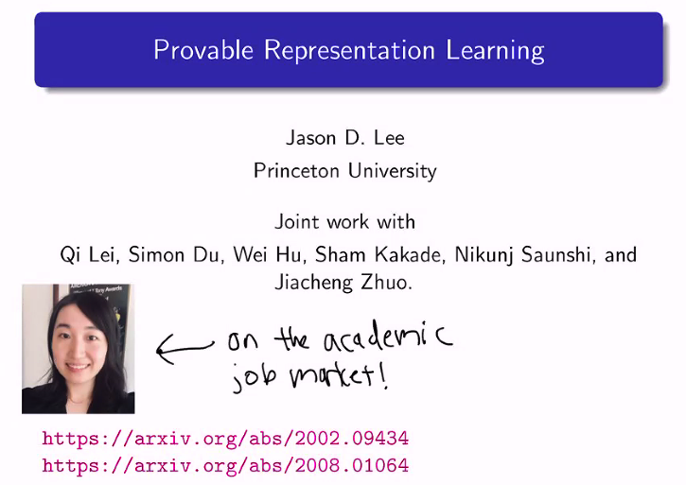

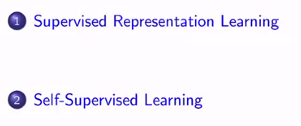

### Part1: Representation Learning

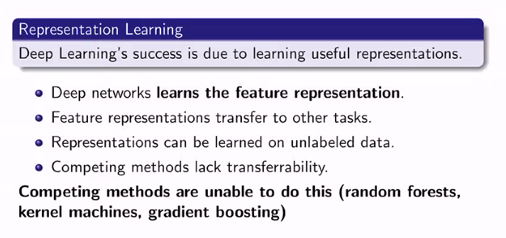

Semi-supervised : unlabeled data, aka word2vec

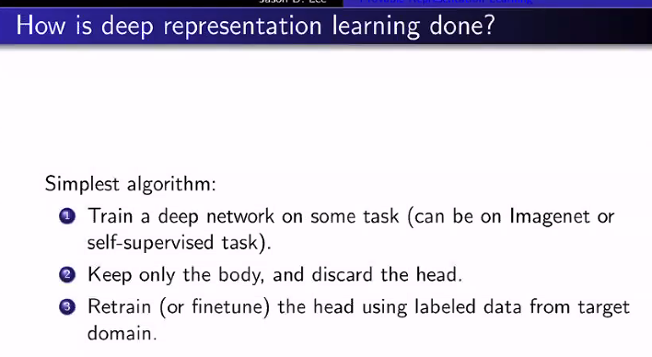

Encoder → decoder

Remove head/ decoder

Fine tune

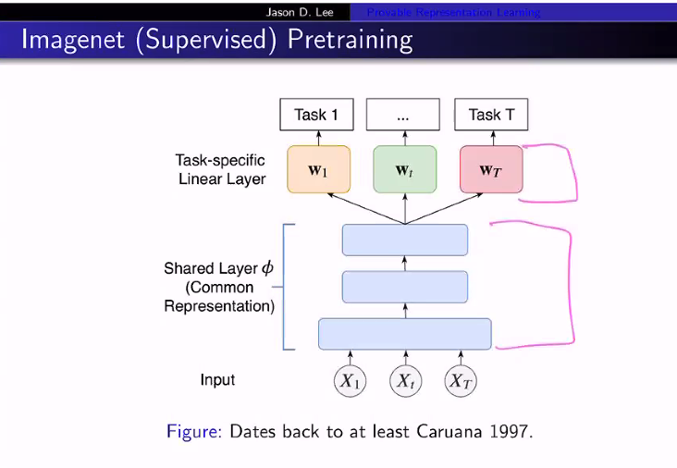

Keep the shared layer

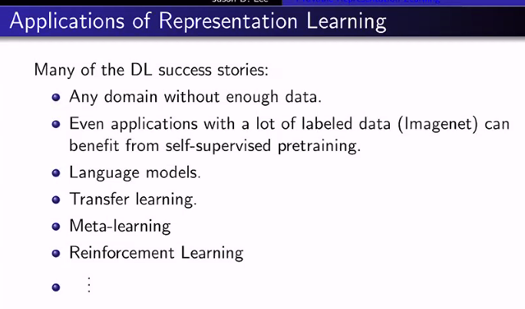

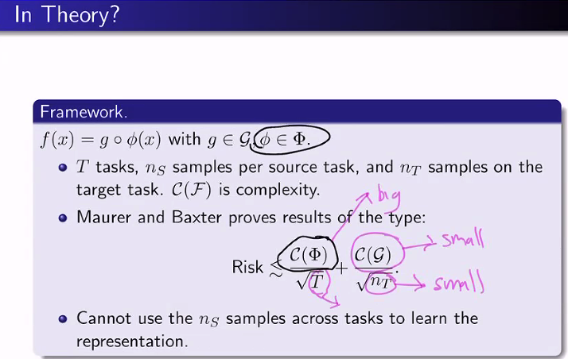

What can be done, what cannot be done

Phi = representation

T = Task;

C(F) = complexity

n(T) = number of samples

The greater the diversity of the data → better representation

### Self-Supervised Representation Learning

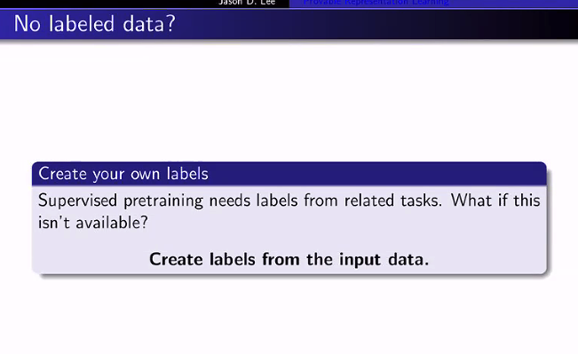

How does this work; from information theory, semi-supervised does not make sense

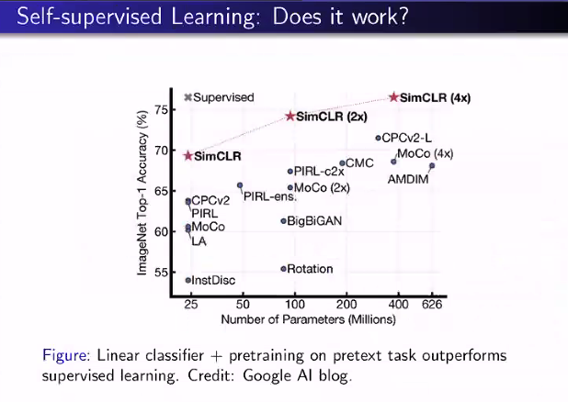

**Self supervised works VERY well**

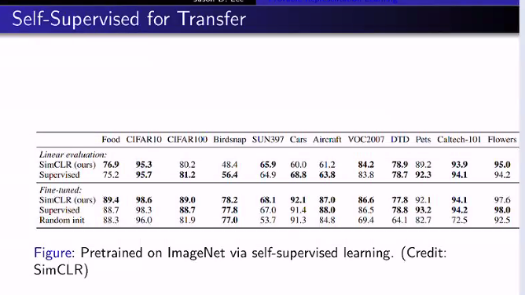

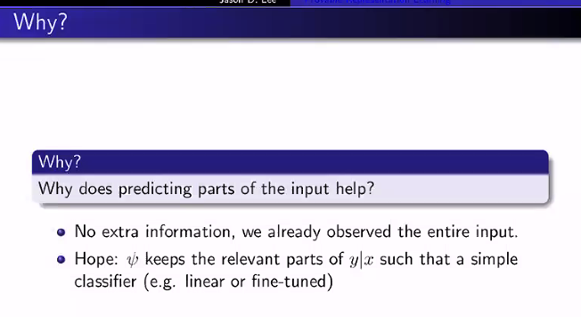

**X is a high dimension.  reduce the dimension of the representation**

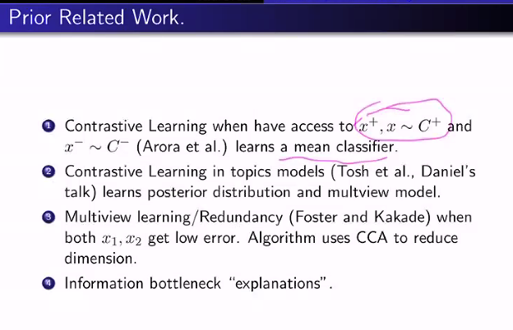

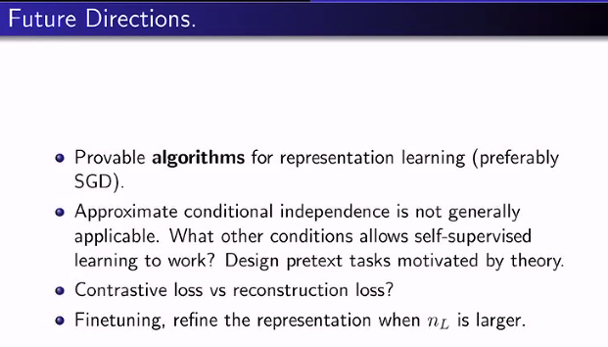

## Andrew Stolman

## 

## 

## 

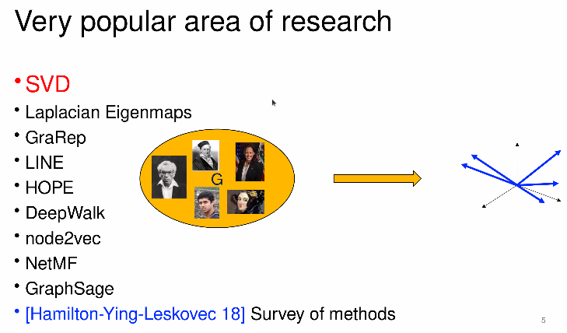

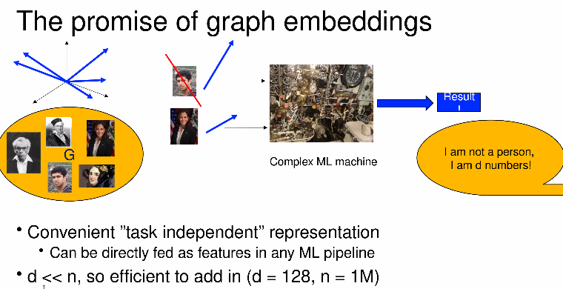

Feed the representation to down-stream tasks

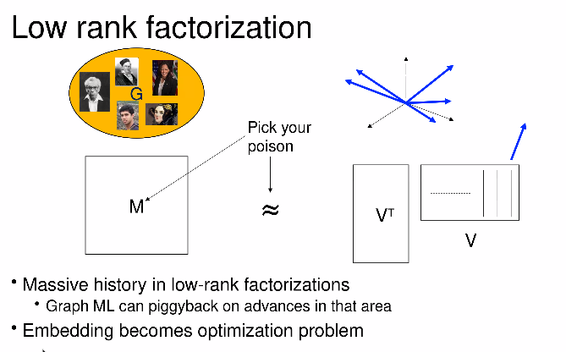

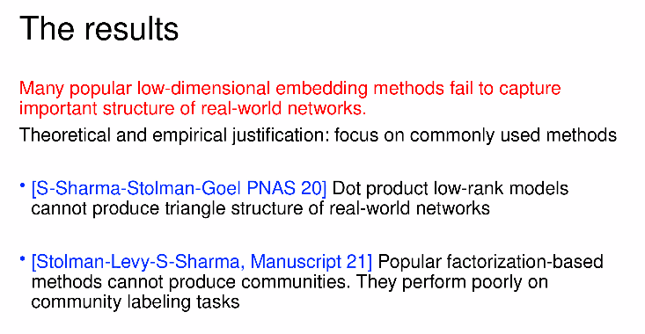

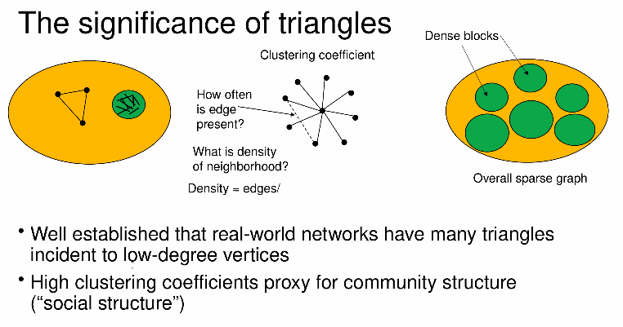

Real networks are sparse, but has high clustering coefficients

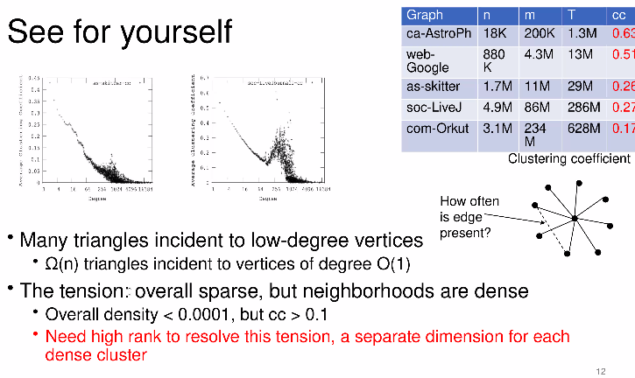

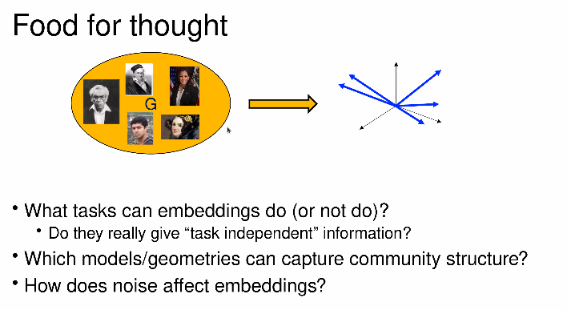

## Why do Large Models Work?

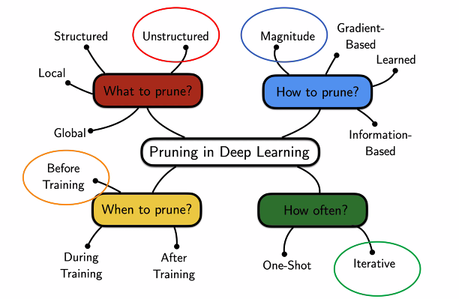

When to prune is one of the key questions.

This talk focuses on the highlighted circle

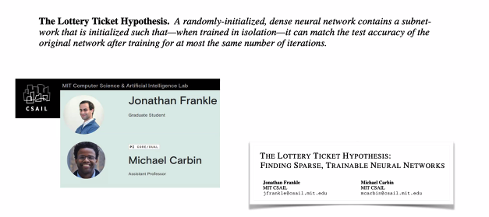

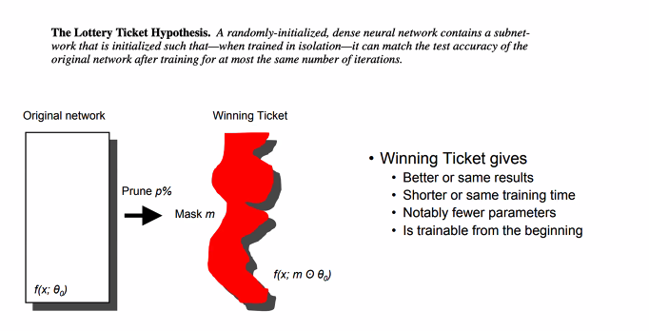

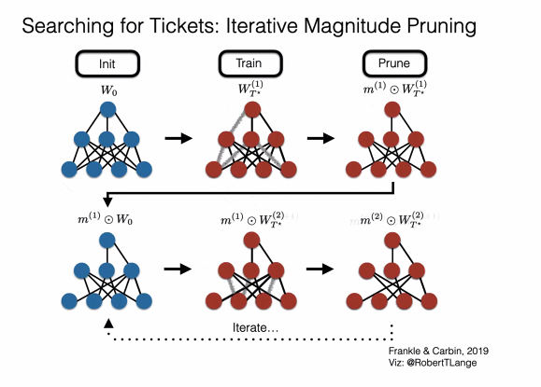

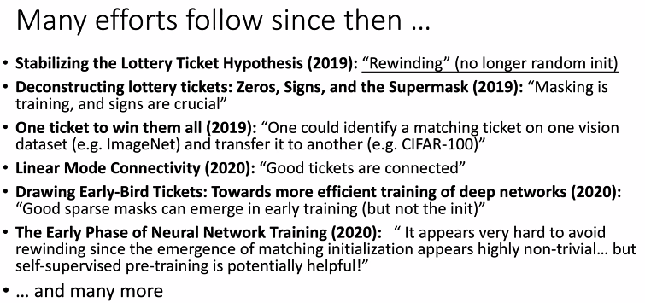

## 

## Yasaman Bahri

## 

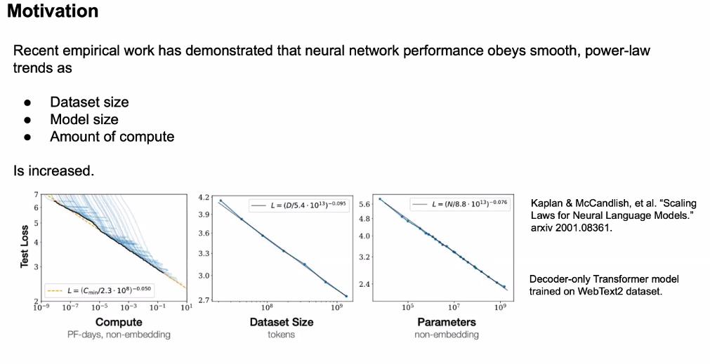

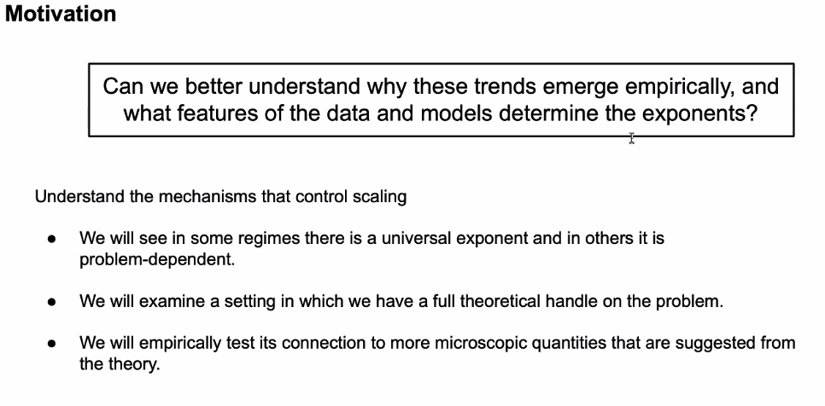

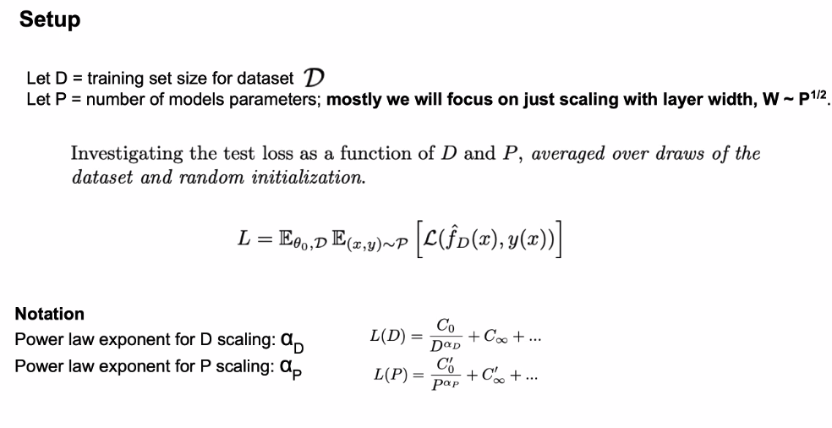

P = width of a layer

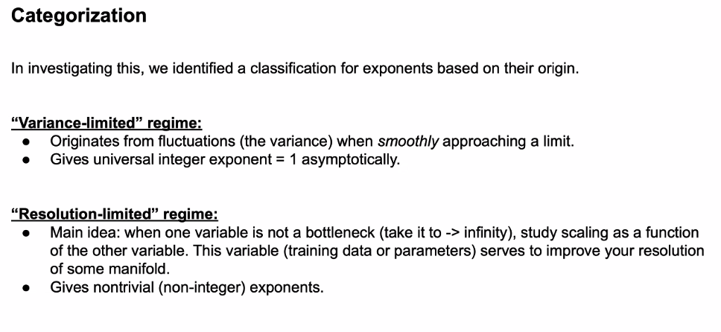

# Part2: Scaling Deep Learning

## Utility Bill ($) of DL Eric Xing (CMU)

8:00-8:30AM

### TRENDS and CHALLENGES

### 

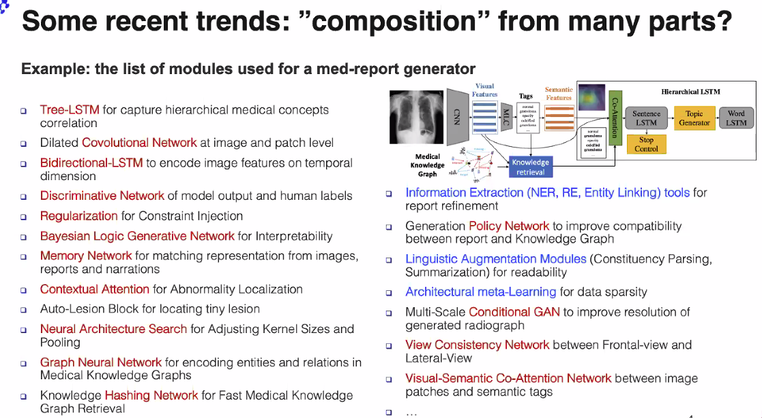

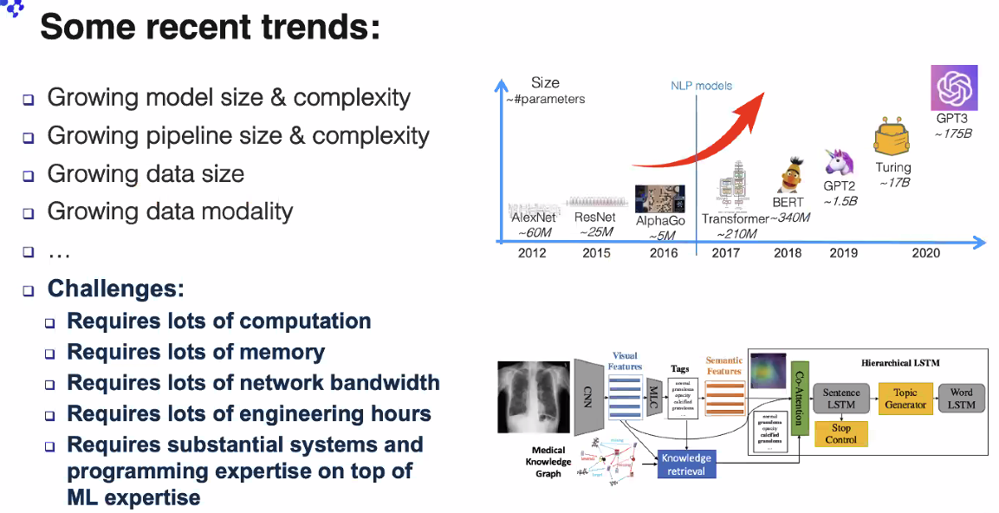

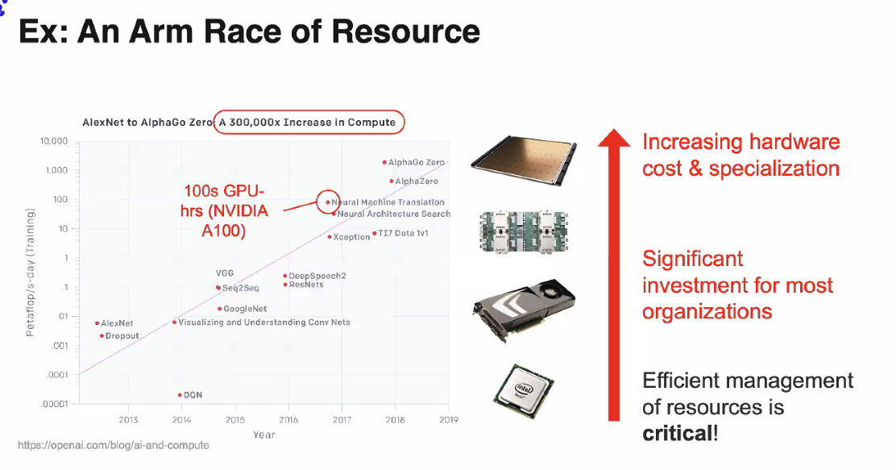

1 million cores per chip!!

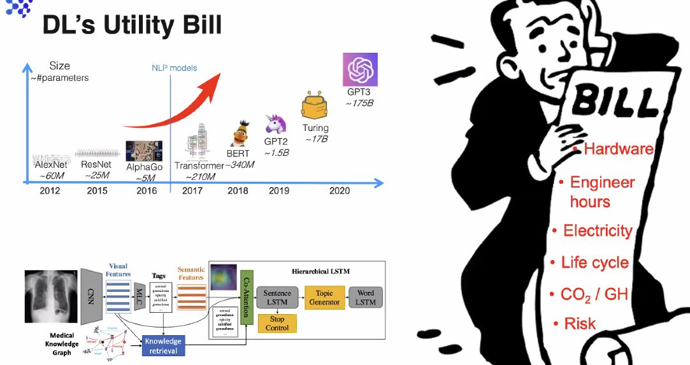

### How to Reduce Cost

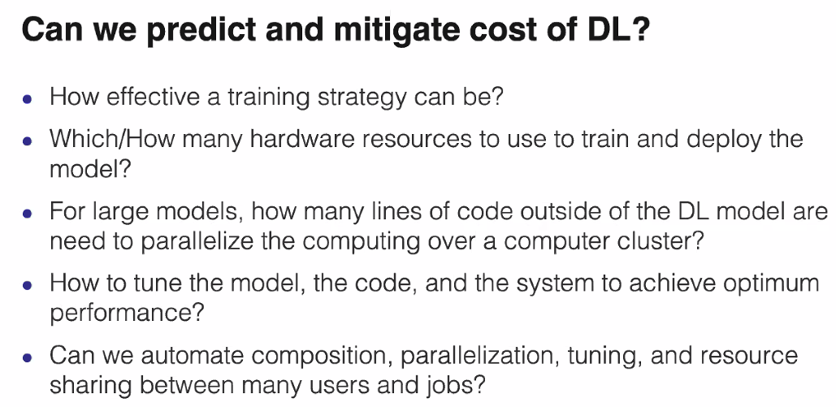

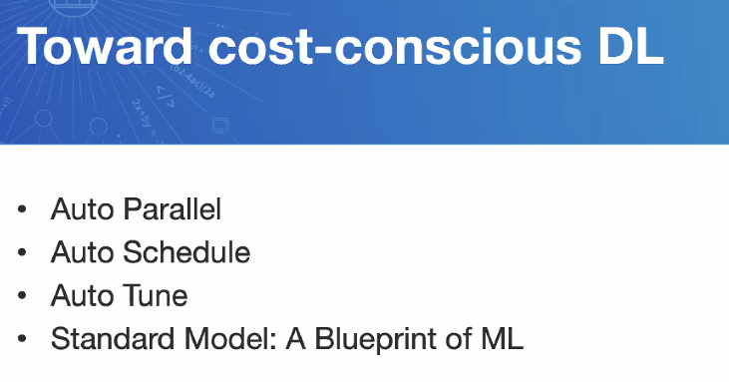

### Auto - Parallel a Model

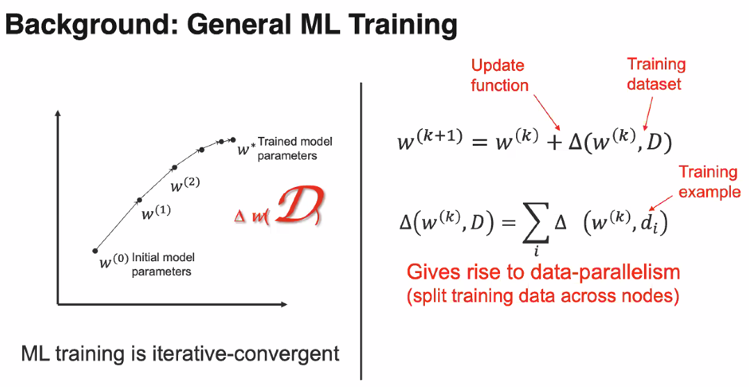

When model gets big, may need to split data or model

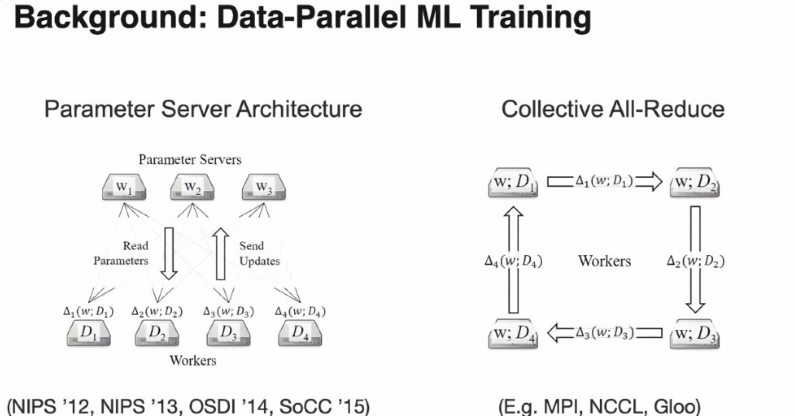

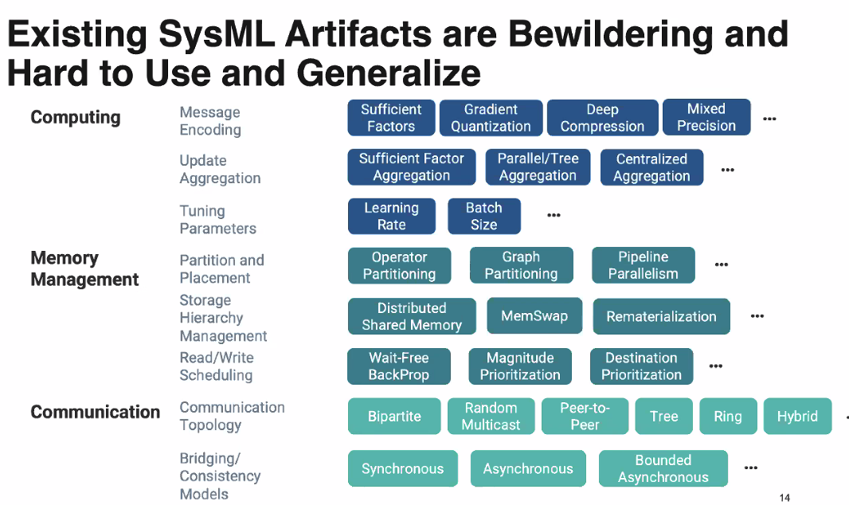

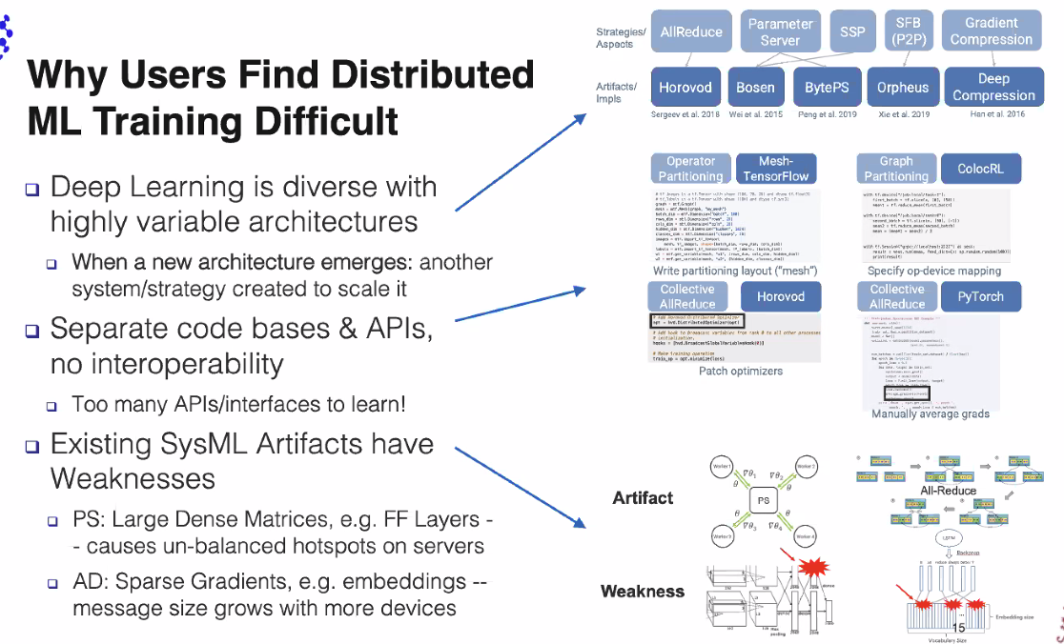

Fragmented solutions. Need to consolidate.

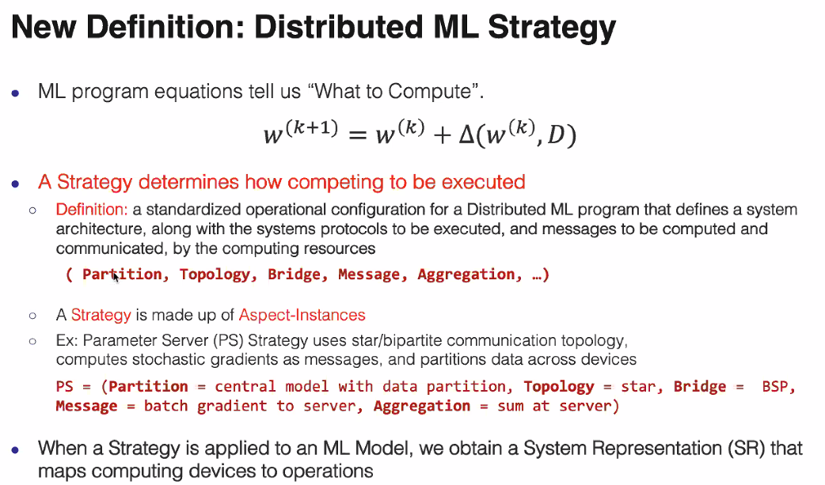

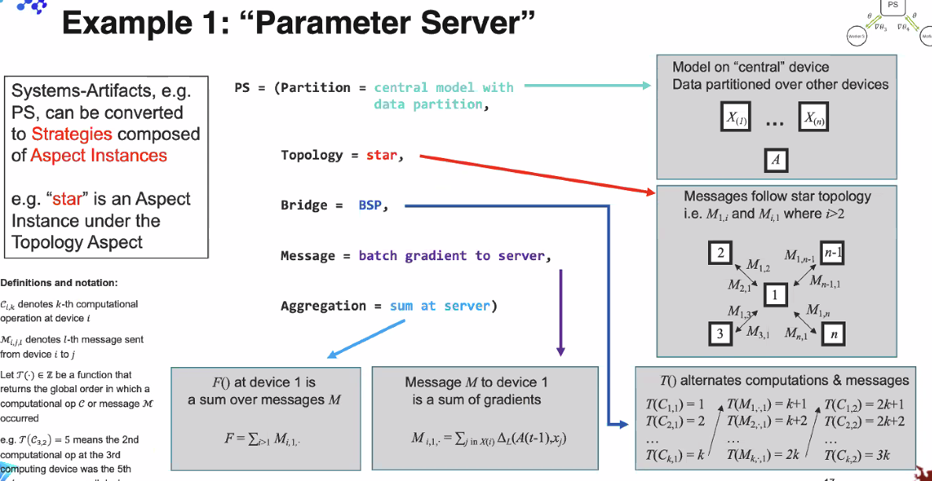

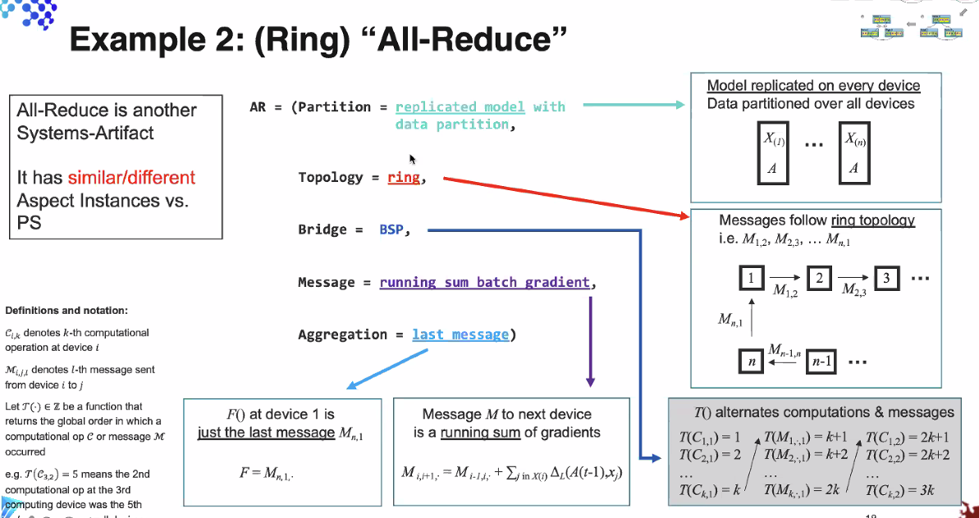

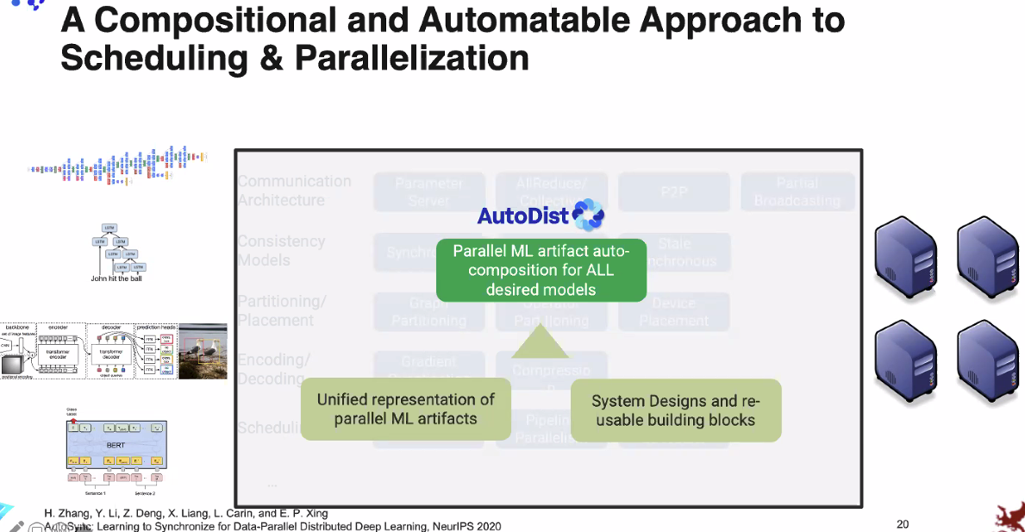

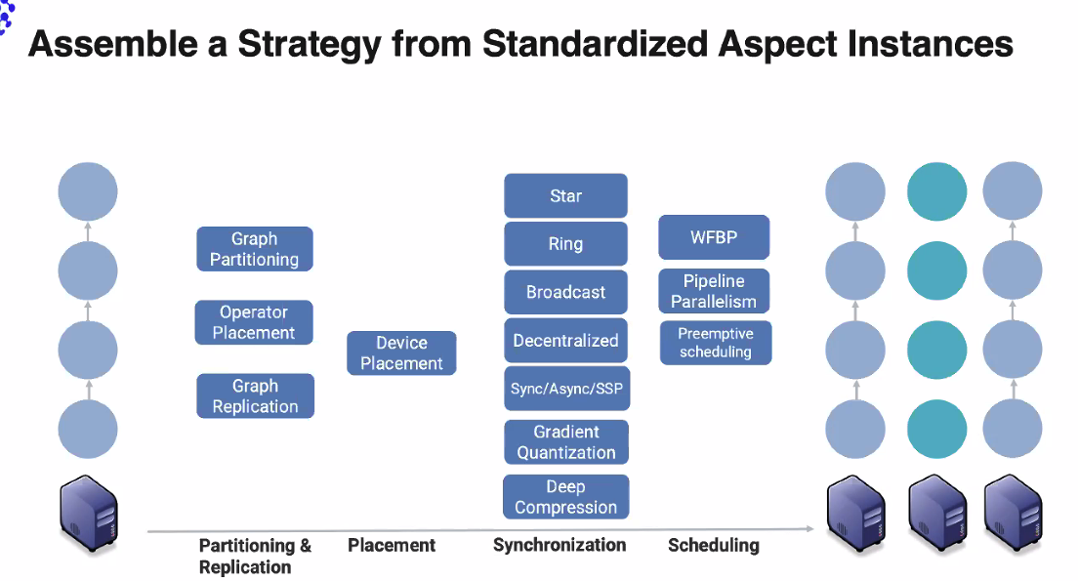

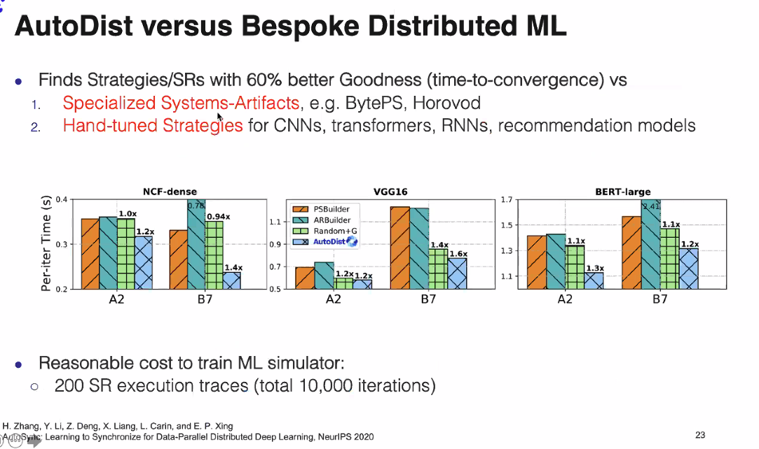

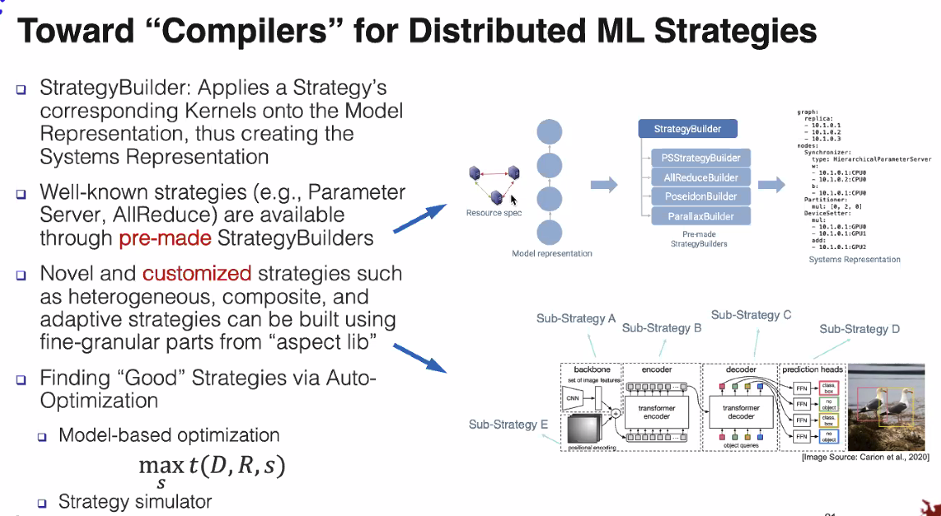

### 

### 

### 

### Auto Schedule: How to schedule multiple Tasks

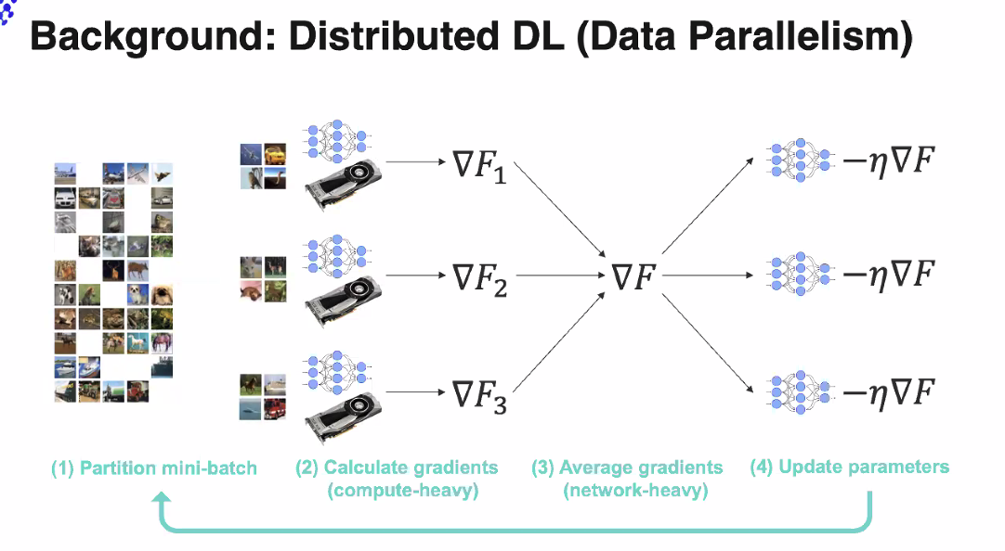

2 design spaces: learning rante and batch size, but this is not easy

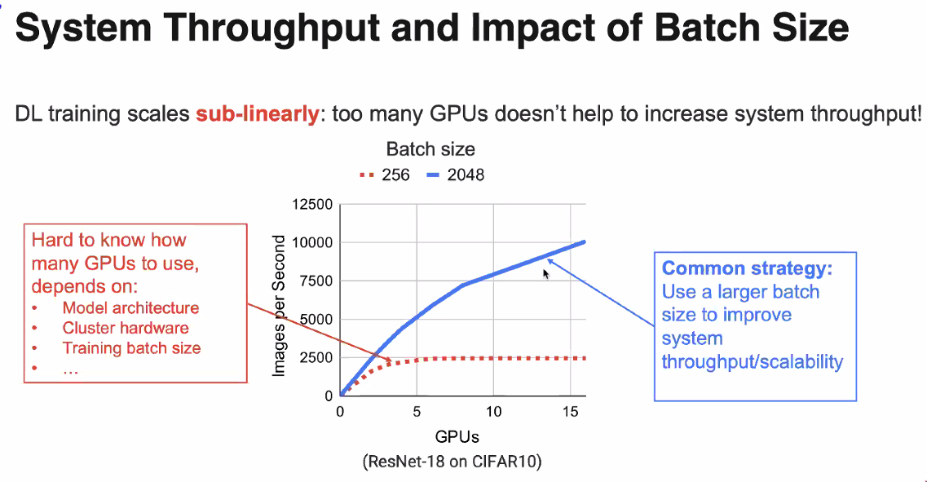

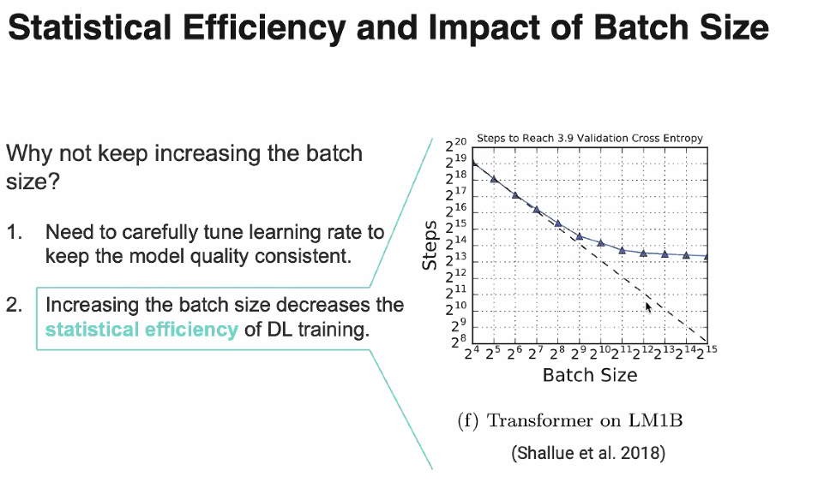

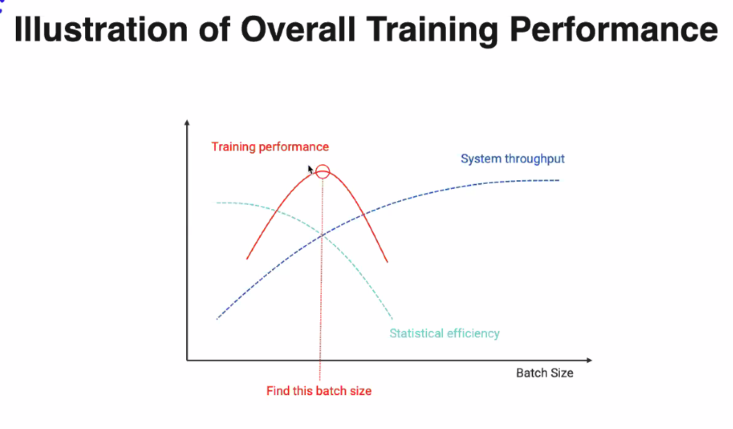

But this ideal batch size changes during training; need fluid resource requirement

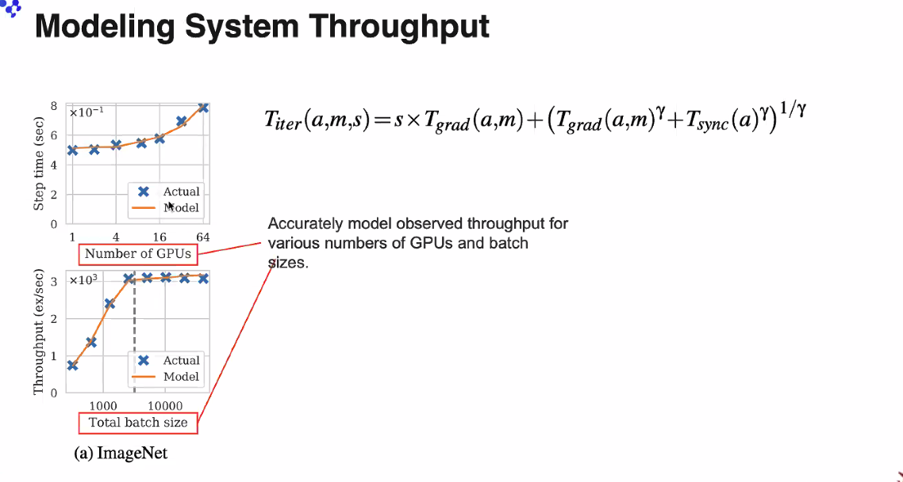

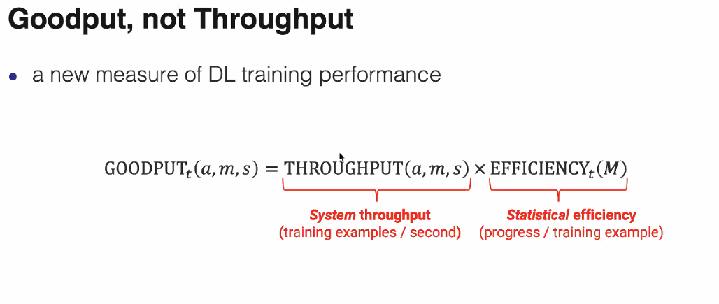

Add efficiency as part of the toroughput. Used this new metric for scheduling/allocate resources

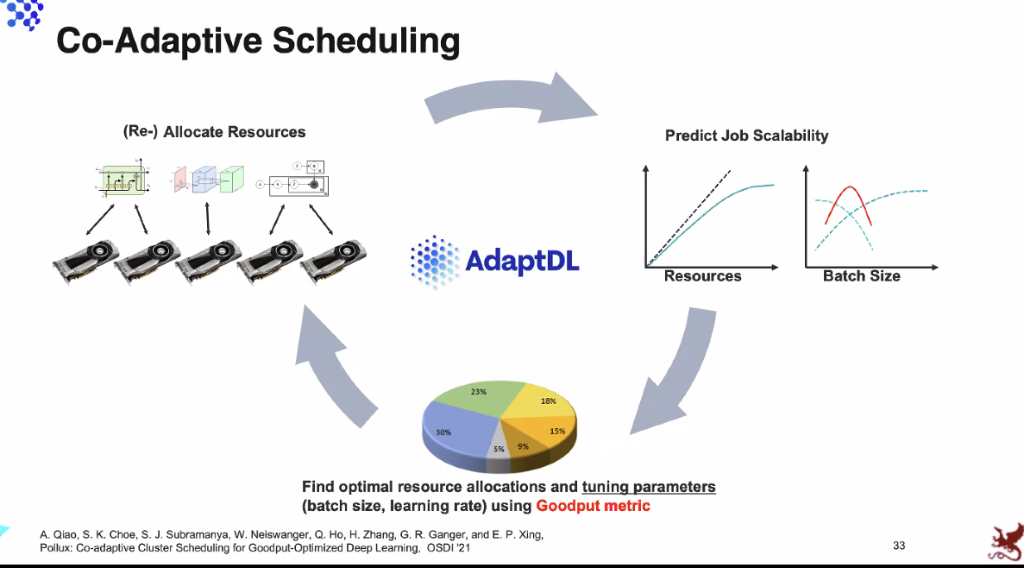

### 

### 

### Auto Tune

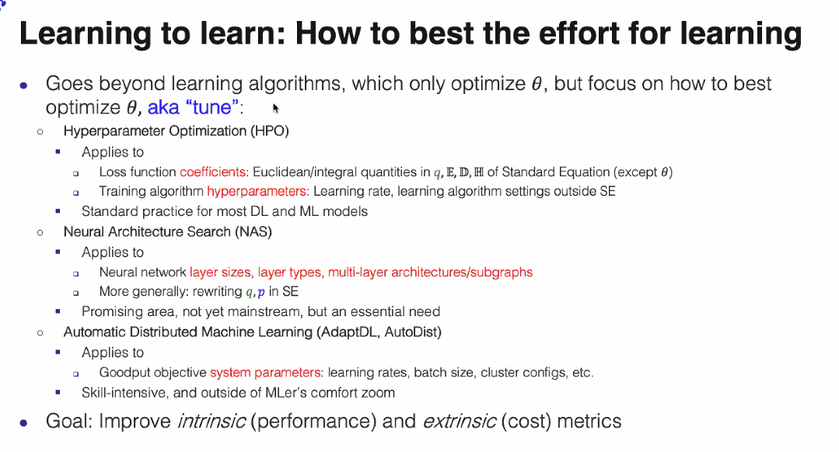

All these tuning knows can change

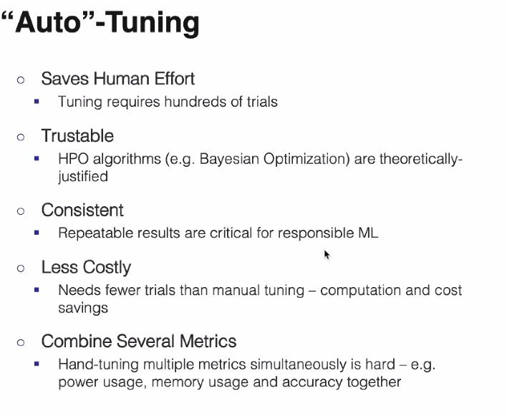

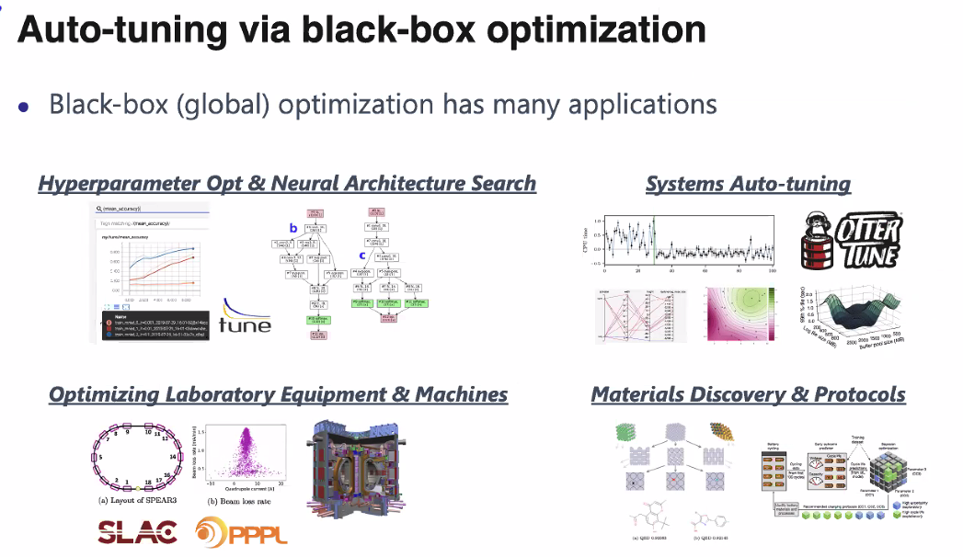

Black box: you don’t know the internal; just treat it as a function

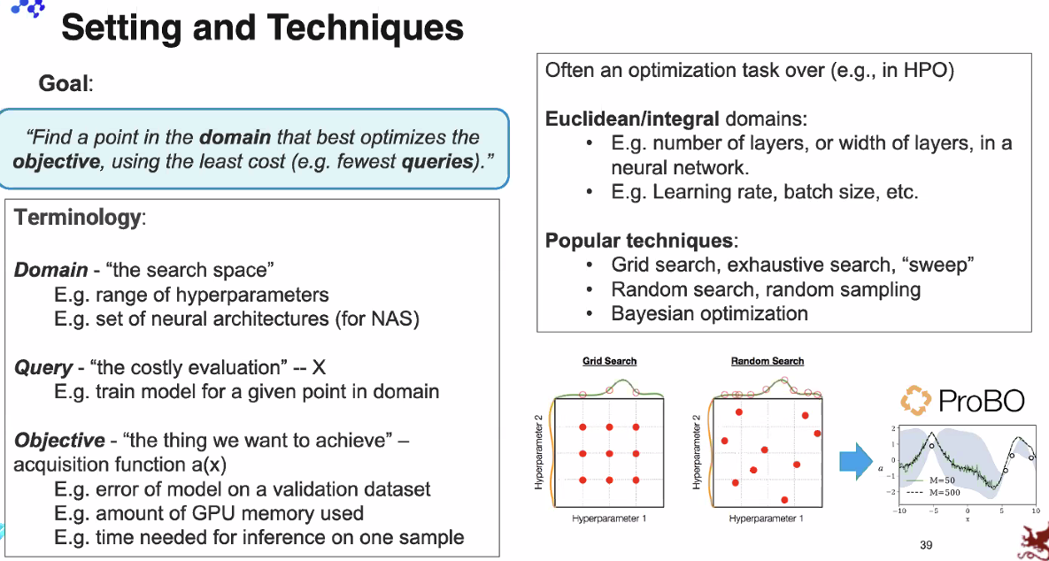

Talks about PROBO

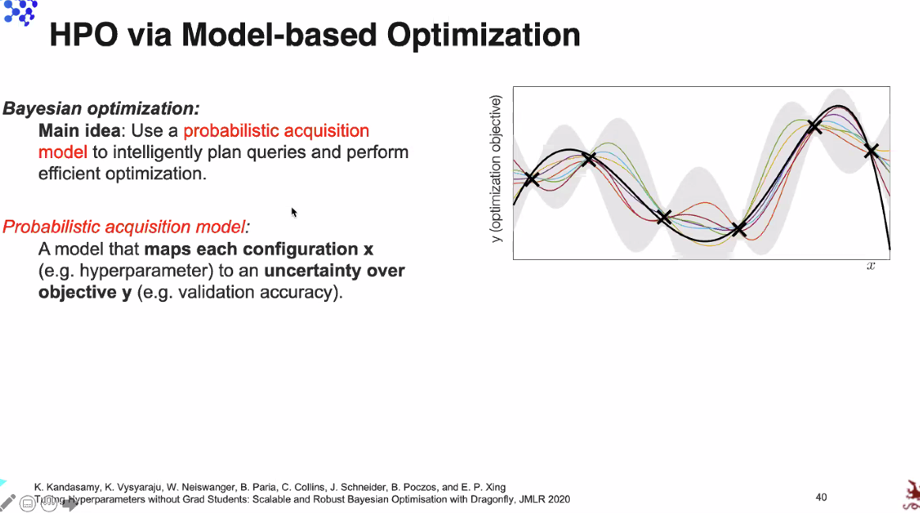

### Summary

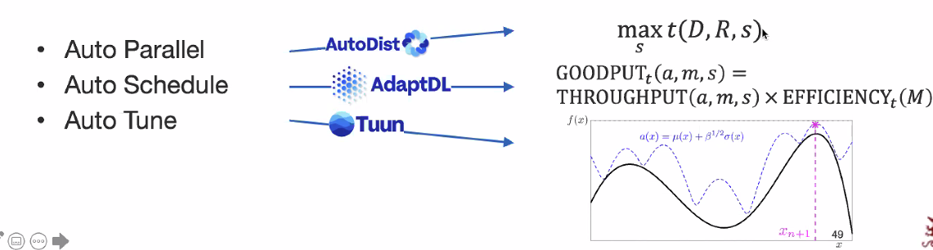

All 3 models uses significant math understanding of ML

### A Common Framework

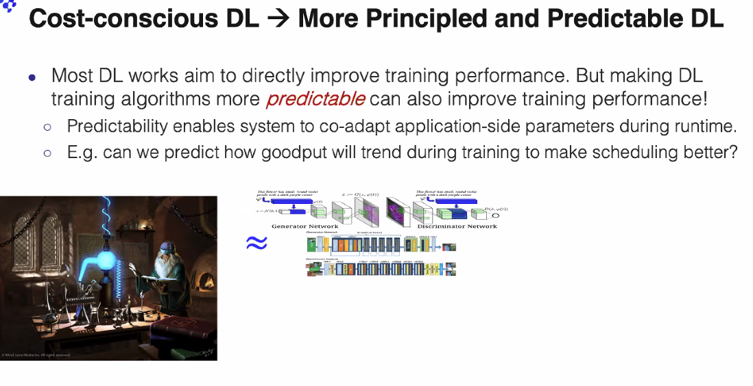

With a framework, with metrics, we can reduce our search space

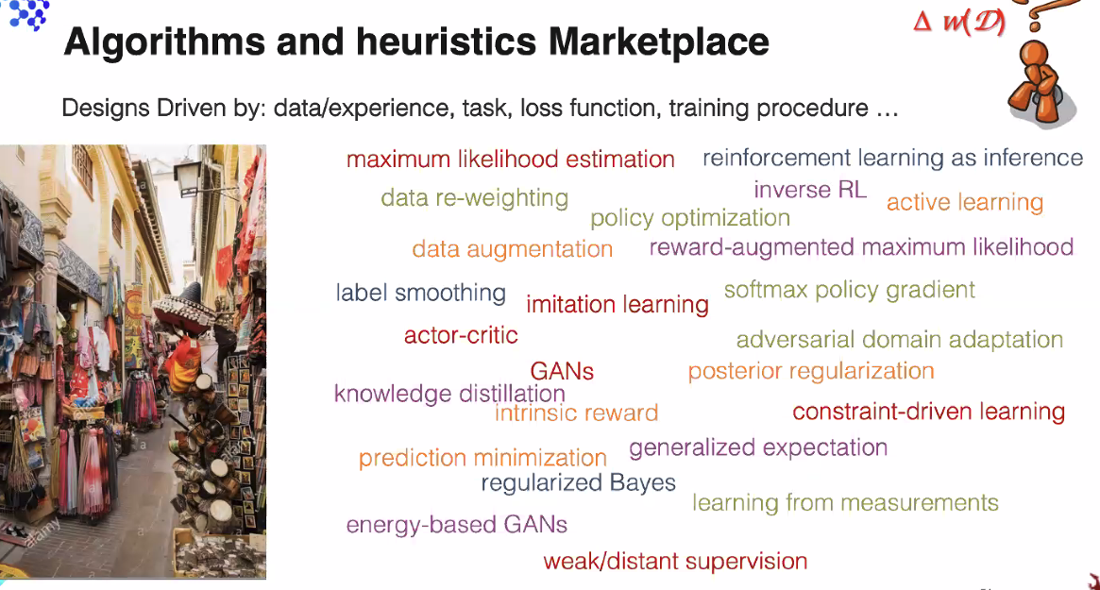

Batch size and learning rate is really hard with all these artifacts

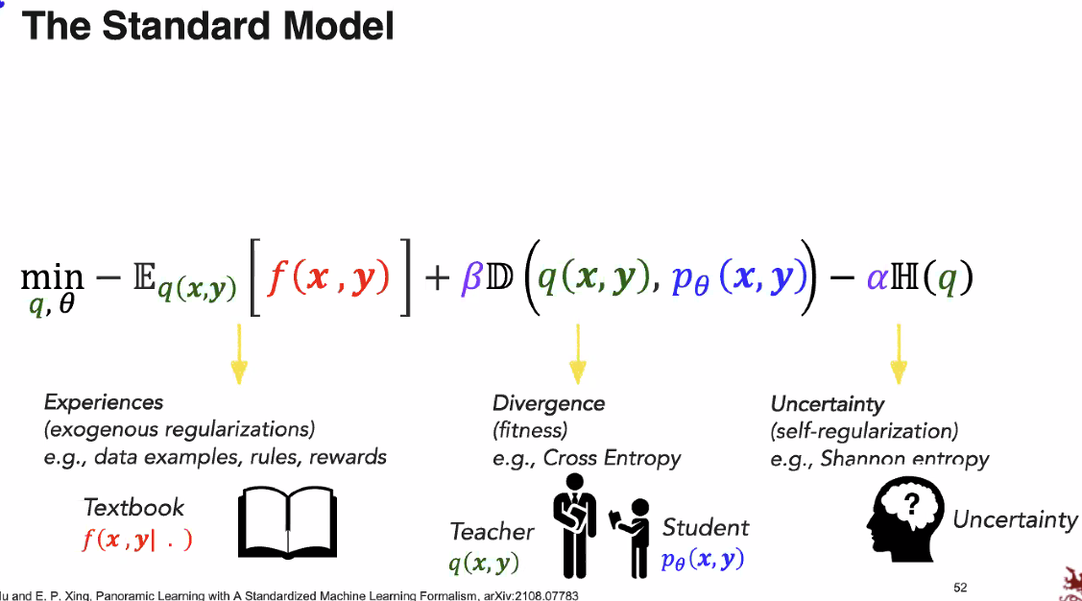

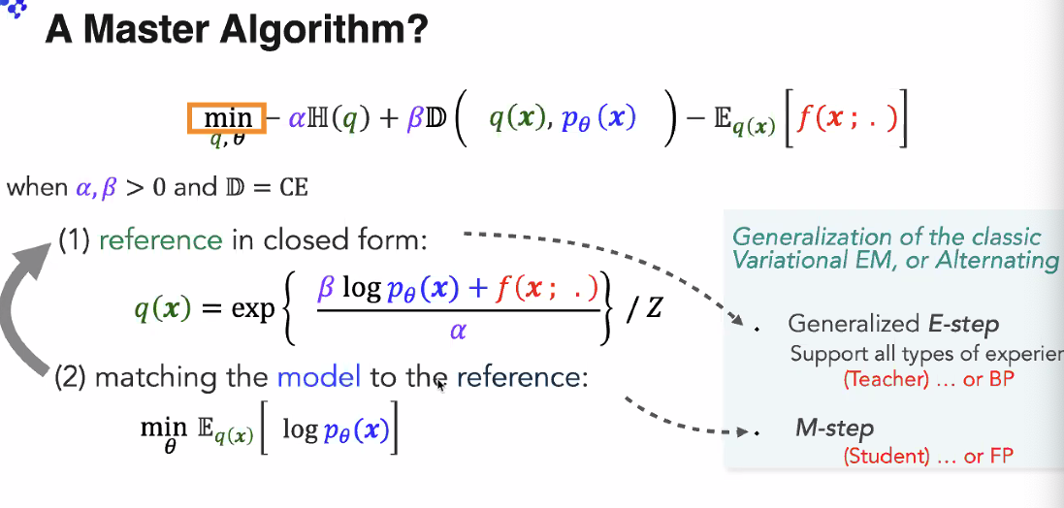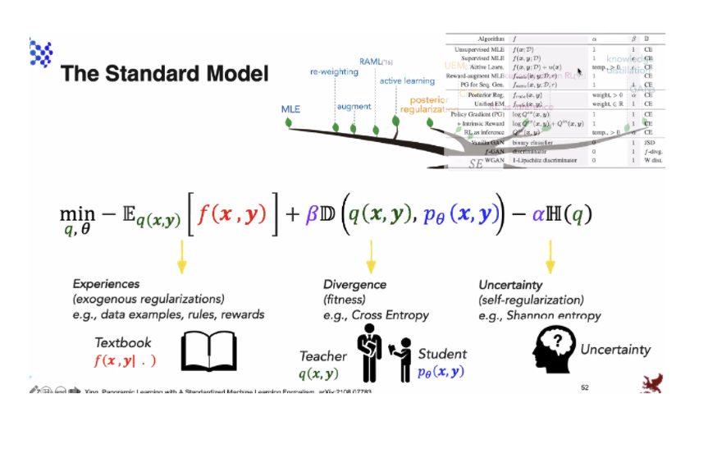

### CODE ([www.casl-project.ai](http://www.casl-project.ai))

<https://github.com/asyml/>

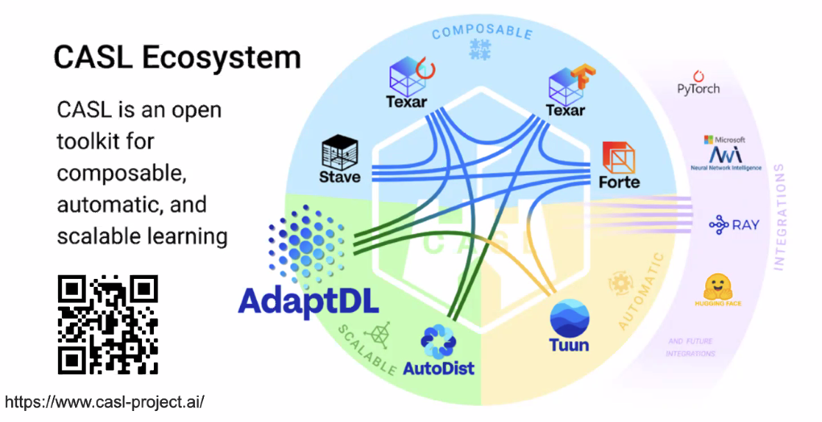

## Arun Kumar (Delusions Of DL)

8:30-8:45

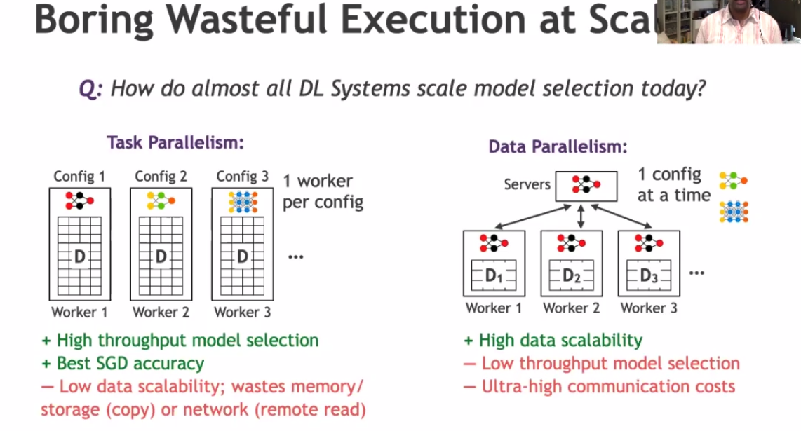

Task parallelism: copy data to task/code

Why just use one

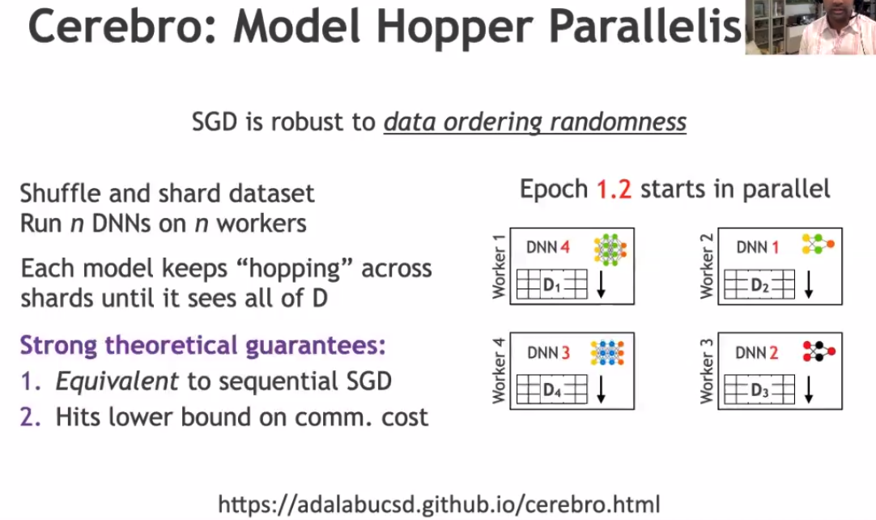

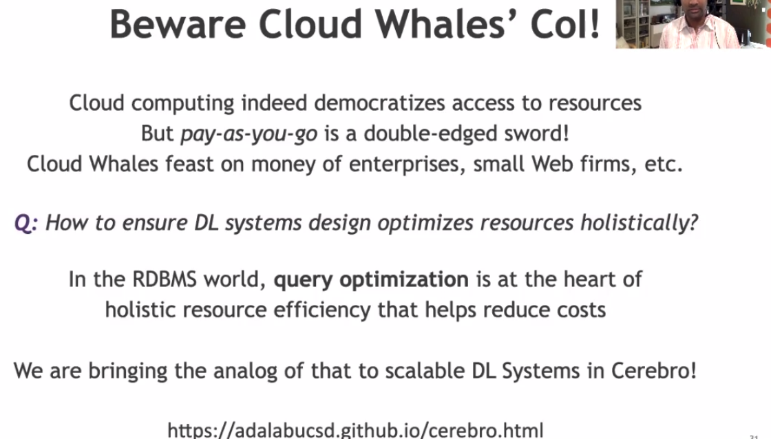

## Toward Building Responsbile Data Ecnonly (Dawn Song Berkeley)

9:00-9:30AM

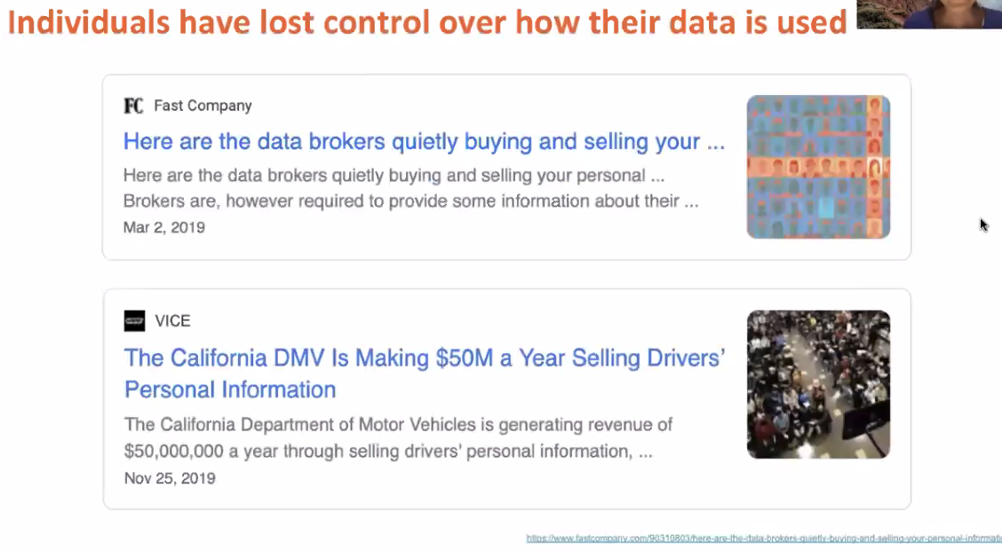

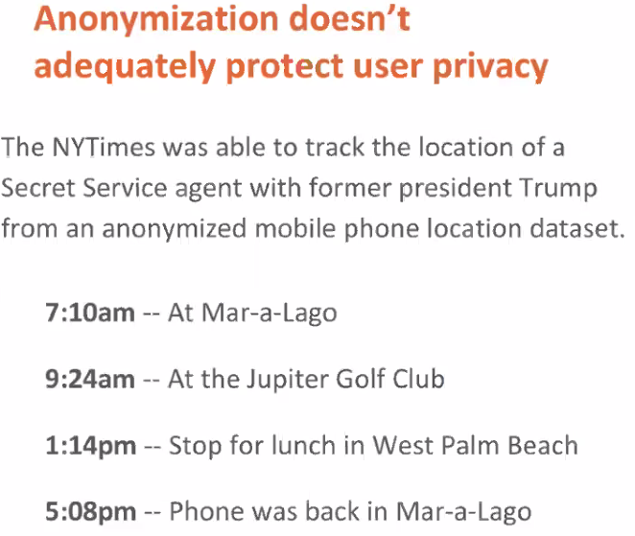

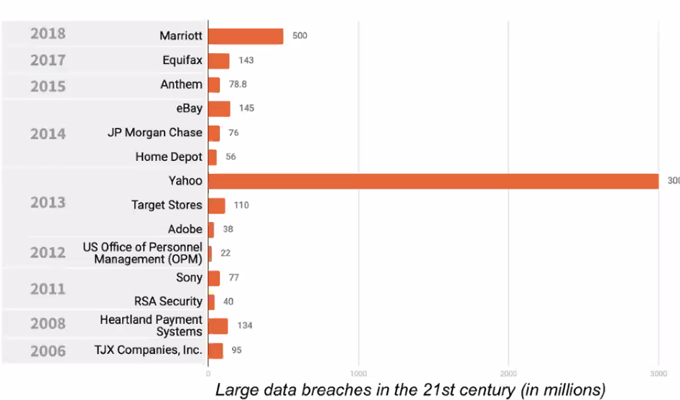

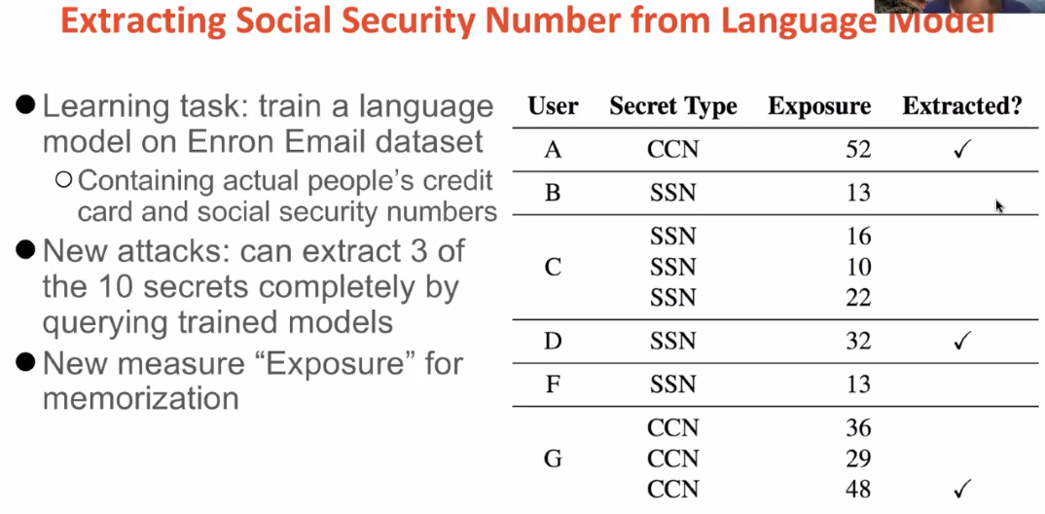

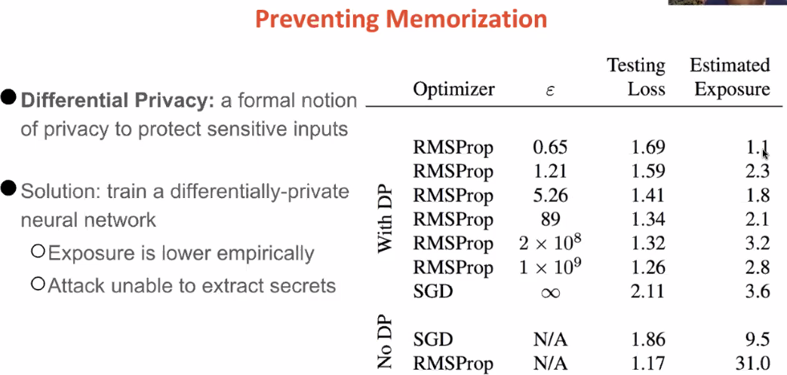

## Deepak Agarwal (Pinterest - Head of Core Engineering)

Industrializing DL for 500m users for engagements

### Pinterest

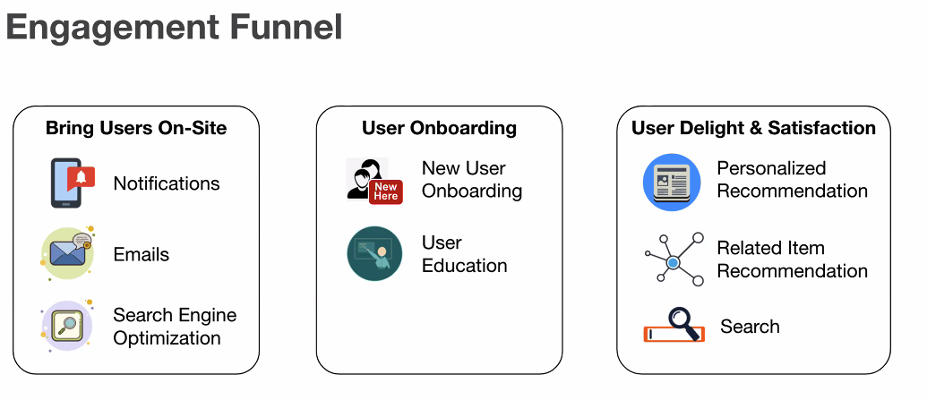

Key surfaces:

Home Feed: user

Search: query

Related Pins: seed pin

Each surface has advertisement

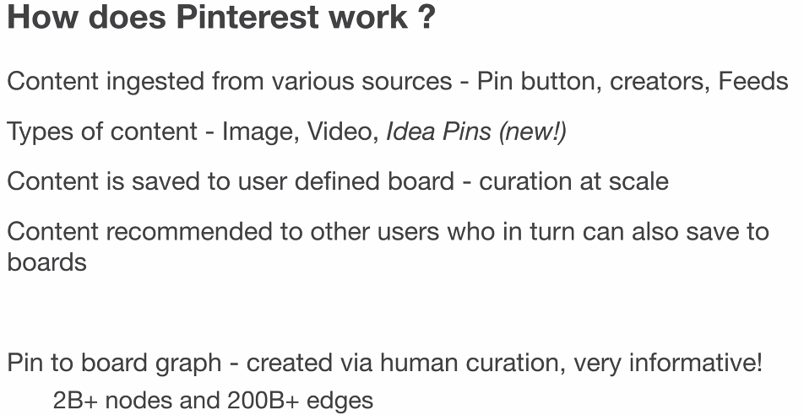

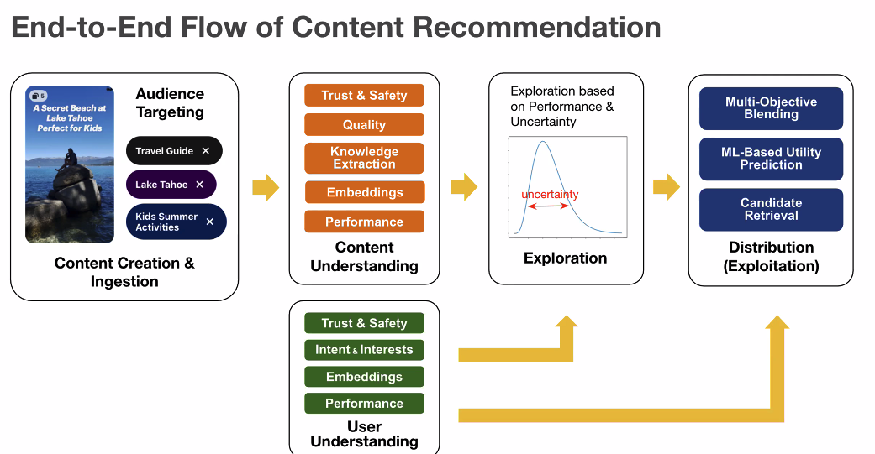

Remove pins that are not high content

Exploration & Exploit: make sure pins have some change

Retreival/Ranking

### Deploying DL Models

Considerations: Cost, developer efficiencys

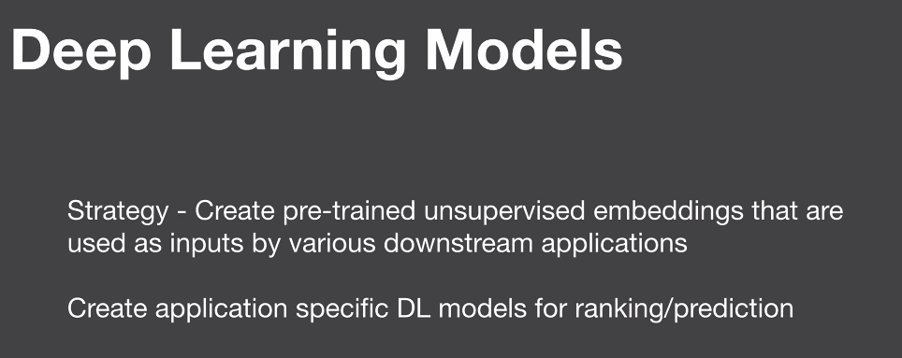

1st stage: unsupervised general embedding

2nd stage: fine tune by application

### Shared/Common Embeddings

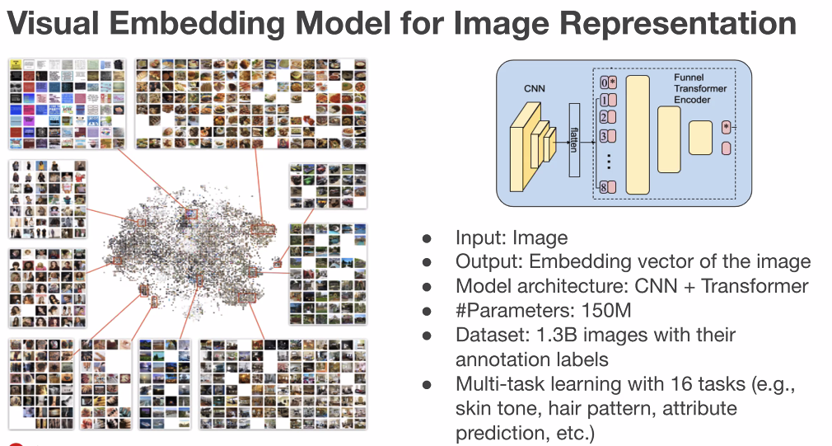

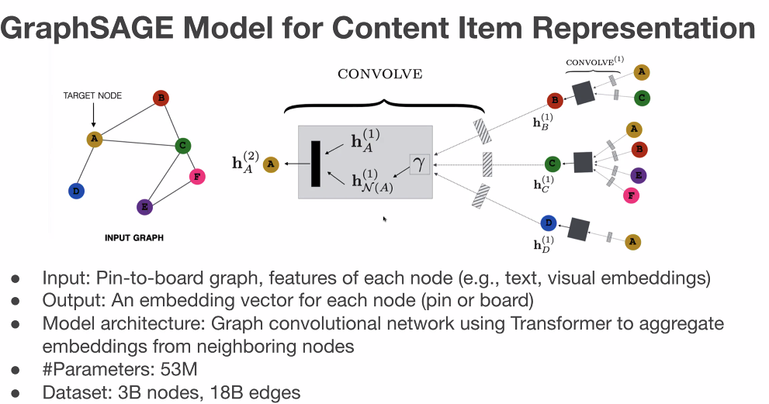

Use graph to smooth out features

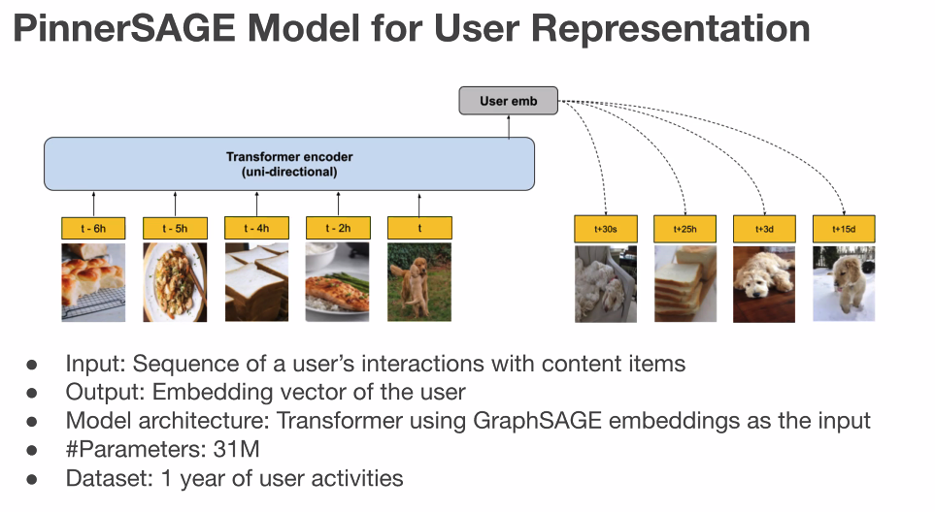

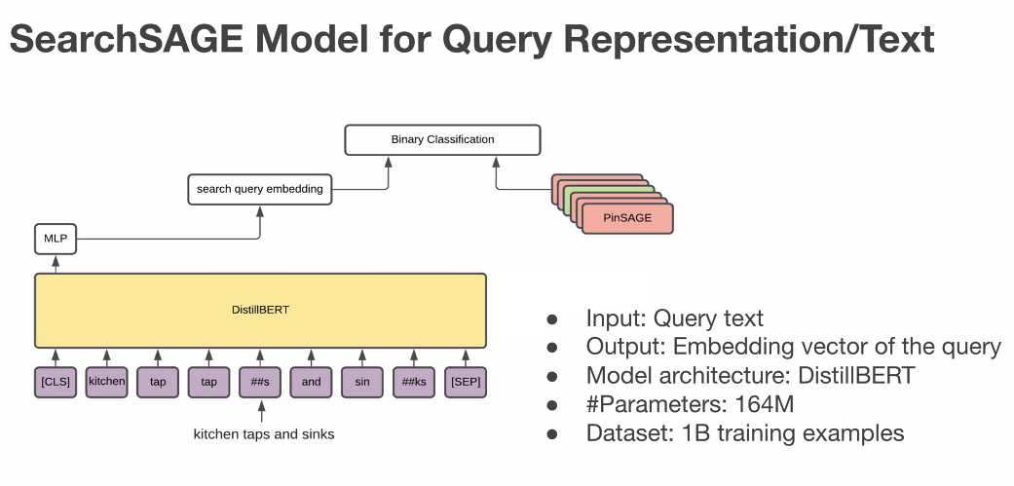

### Application Specifc Models

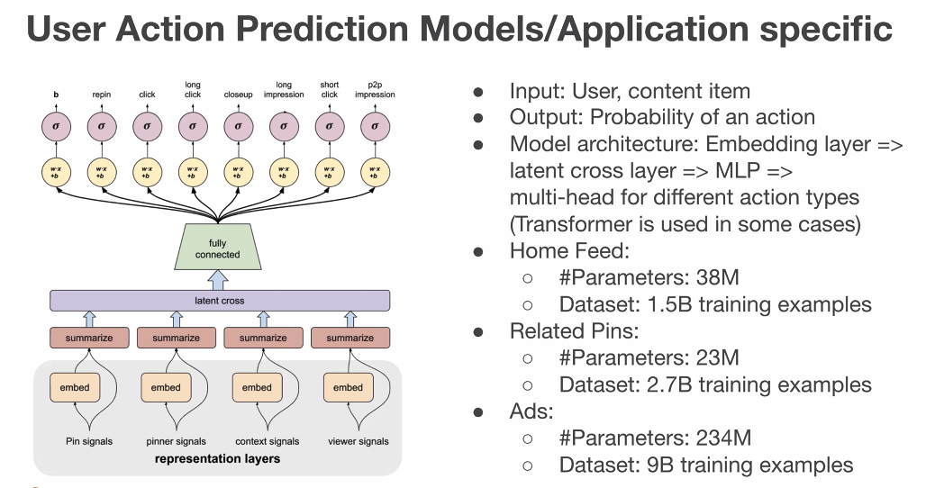

### Engineering:

Goals: Efficiently, productivity, Common Libraries, Reuse

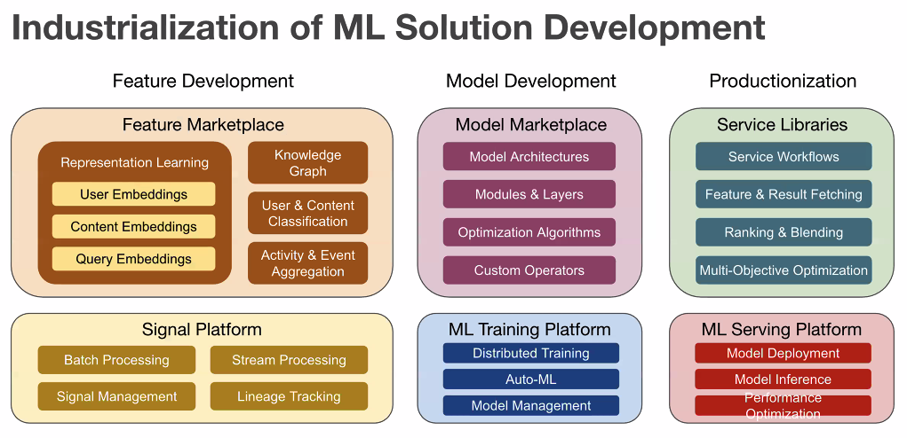

Monitoring: alerts, self healing in some cases

### Deep Dive: Home Feed

Billion pins, pick topK pins in a couple of 100ms

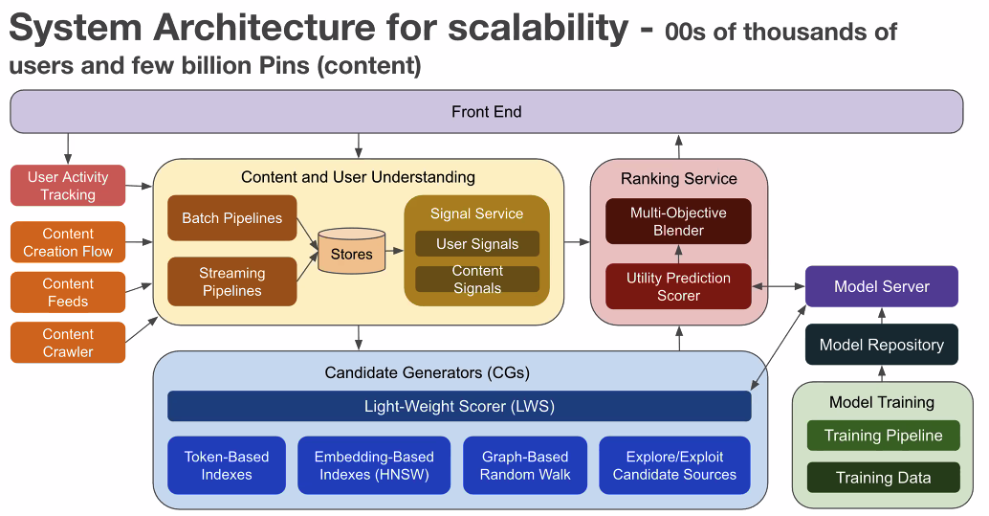

Multi-stage computation:

1st stage → billion to 1k pins

light weight and cheap

Explore and explit

Graph deep walk

2nd stage: multi-objective

Self learning through feedback loop

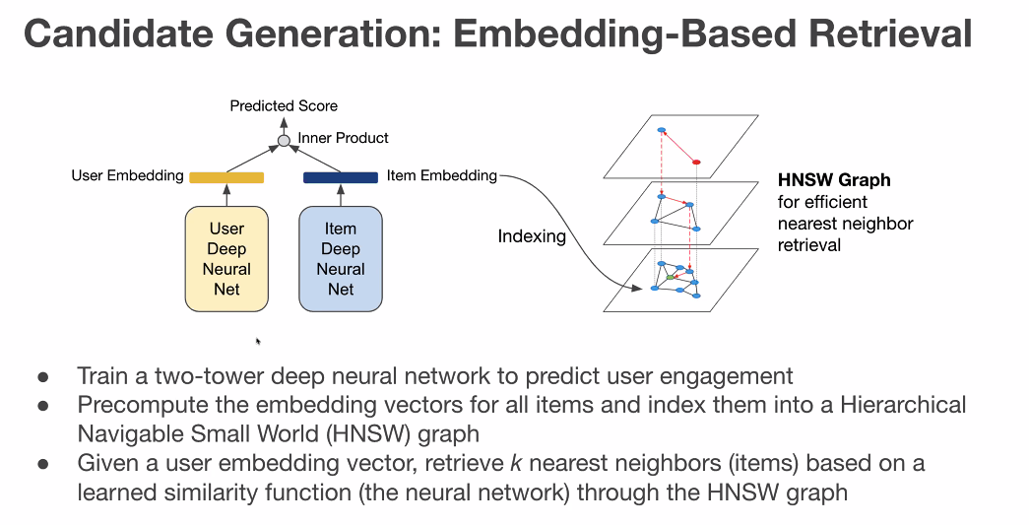

Two tower network; learn pins and user offline

Use HNSW graph

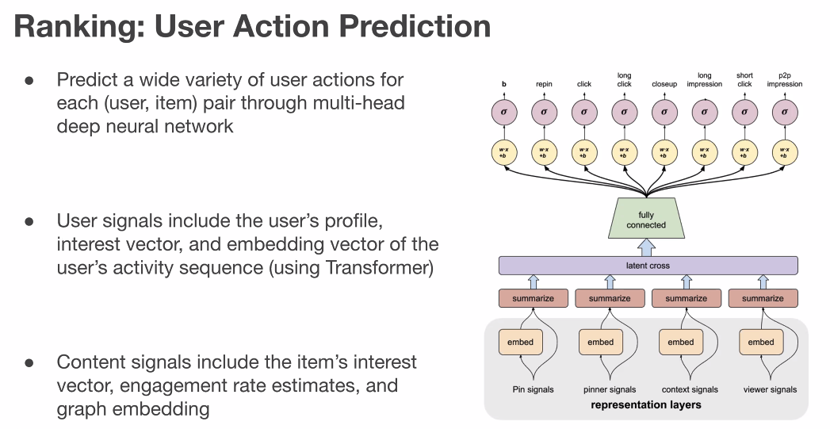

Predict action | user, context, content

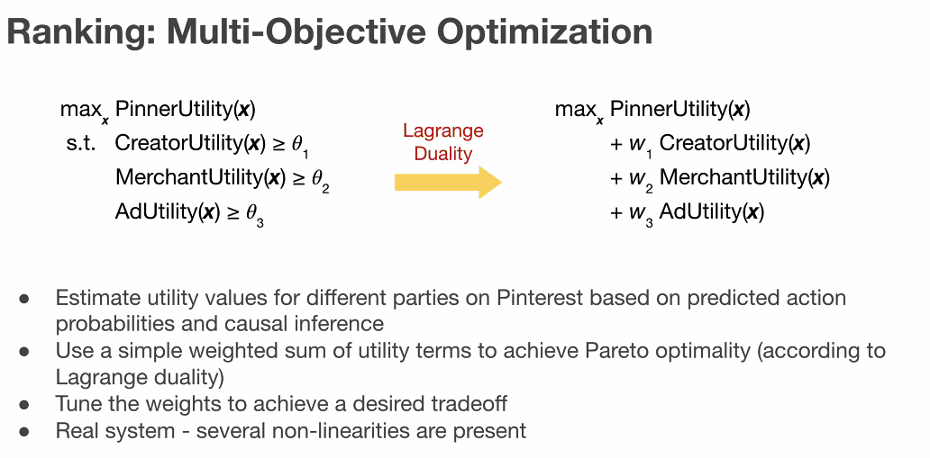

Use Bayesion Optimization to calculate the weights (??)

### Conclustion

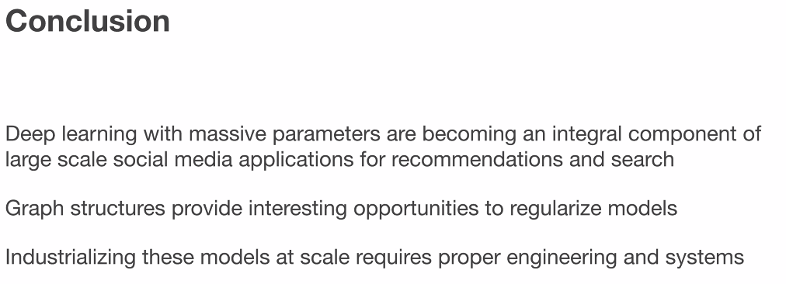

8-10 years ago, matrix factorization

Use graph to regularize model (>=?)

Complex models may cause productivity drag; need alot of industrialization. If release only one model takes 2 months, this will cause lots issues.

# Part3: Fairness and Transparency of Deep Learning Model

## James Zou (Stanford)

1:00-1:30PM

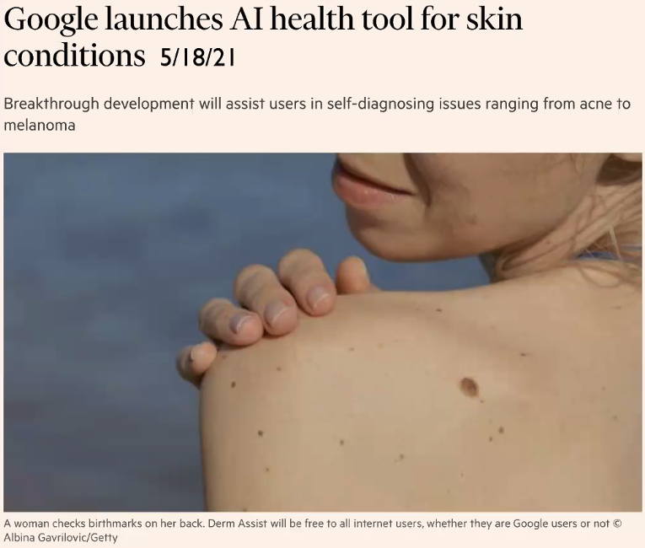

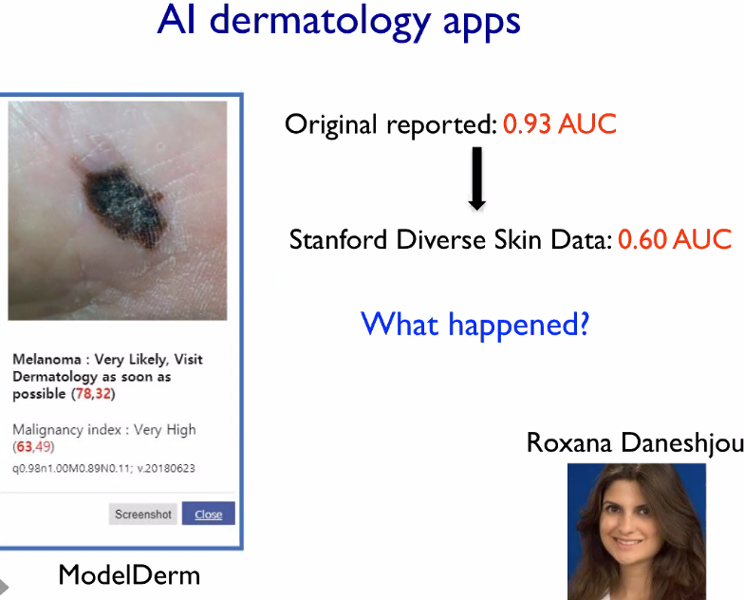

Stanford data came from actual patients

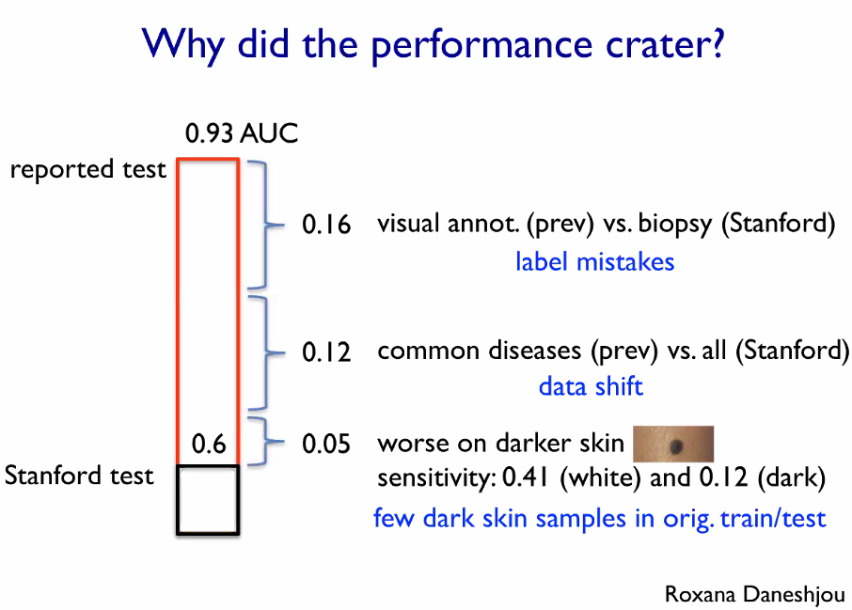

Thre were not as many dark skin samples

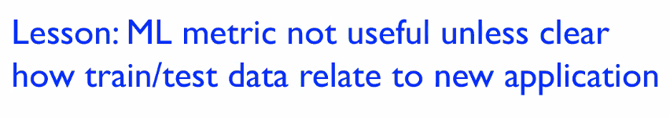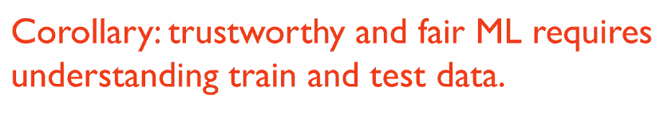

How does train/test relate to new application

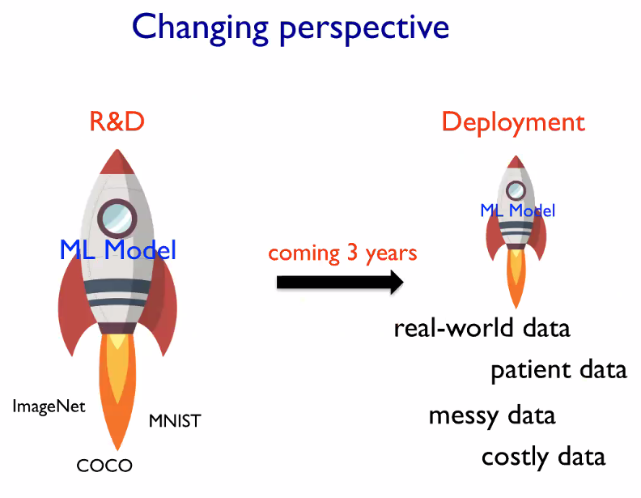

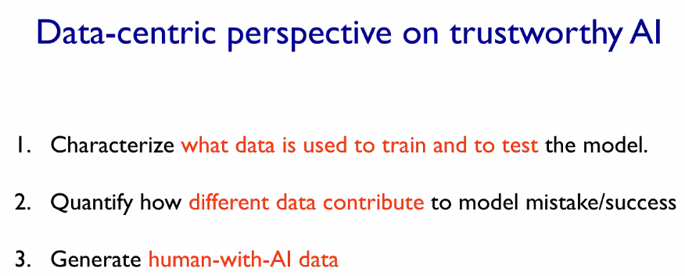

### **Challenge 1: Characterizing the data**

A large number of paper is based on private data

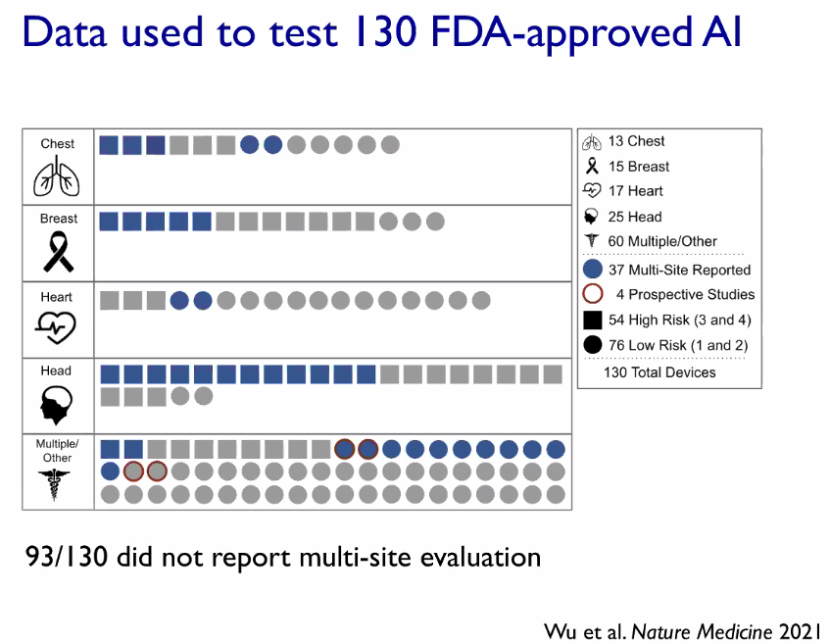

What’s multi-site evaluate? More than 1 location

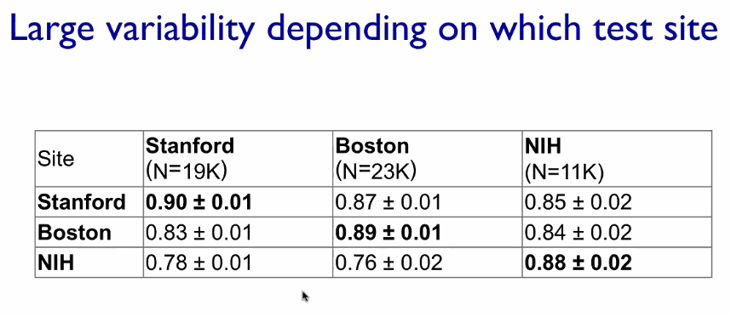

We need to systematically describe the dataset !!!

### **Challenge 2: How do different data contribute to model behavior**

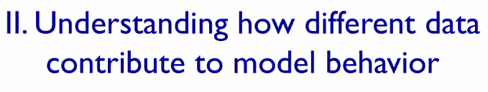

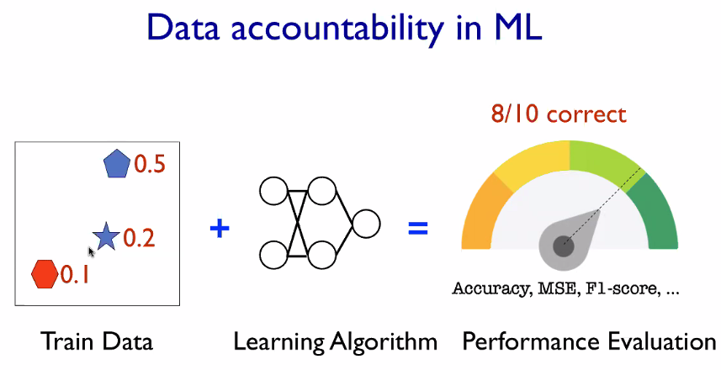

How much does each dataset contribute to my accuracy/mistake? Have a fine grain way to understand the problem

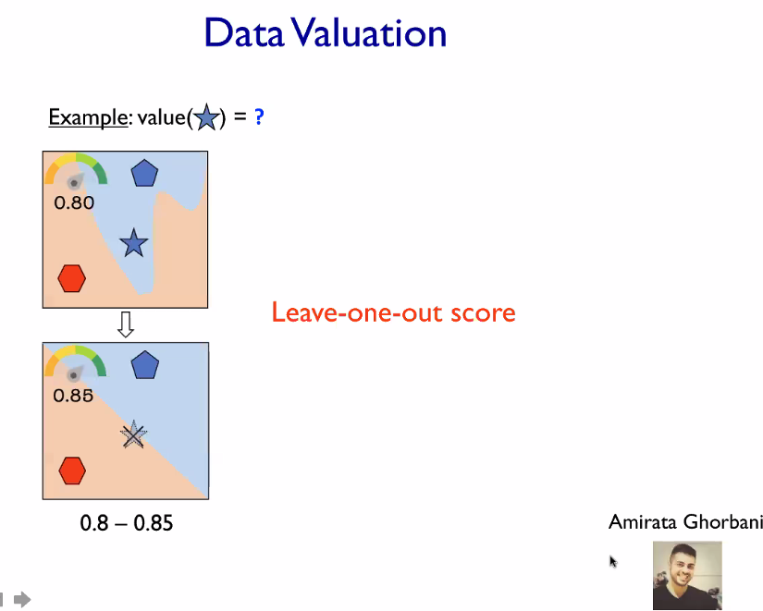

This seems promising, but hard to scale

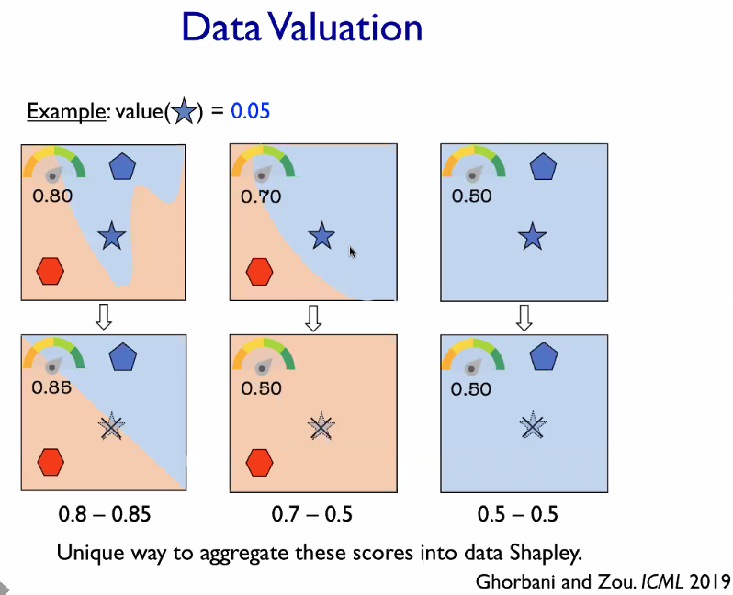

Spilt dataset into sub-dataset; combine via a weighted score

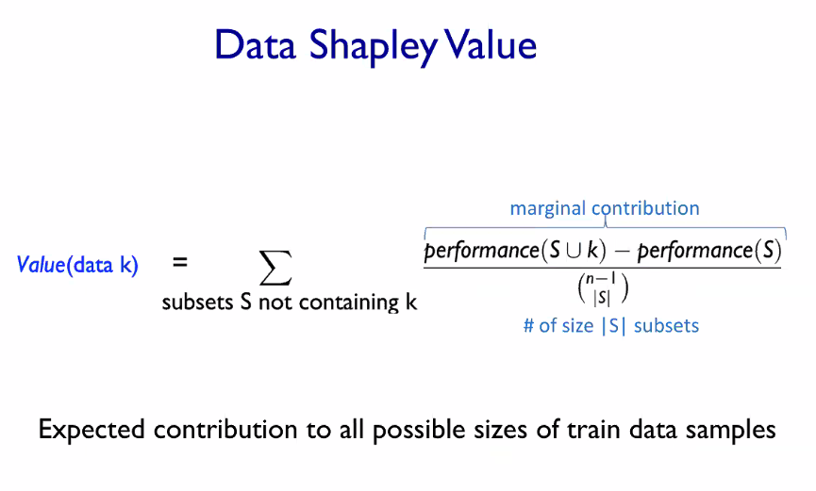

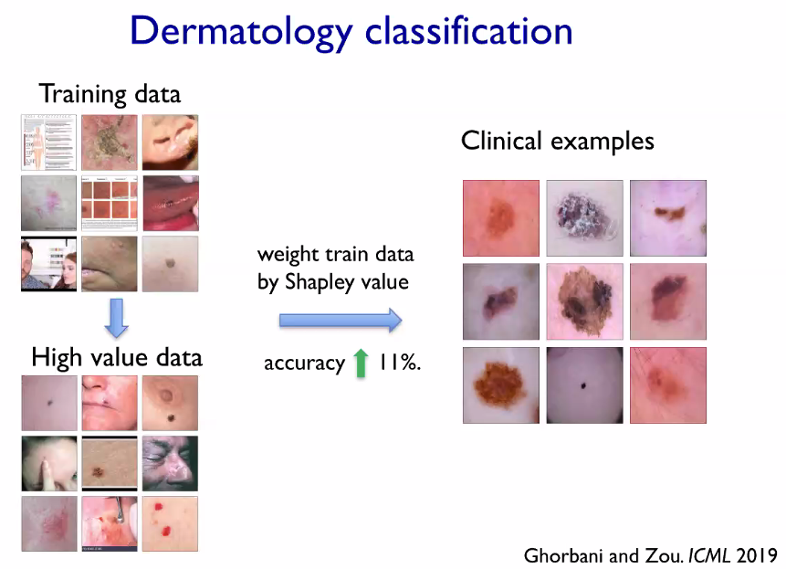

Each training data has a score, which denotes how much it contribute to the right. +1 helps; -1 hurts. We then weigh the data by shapely value.

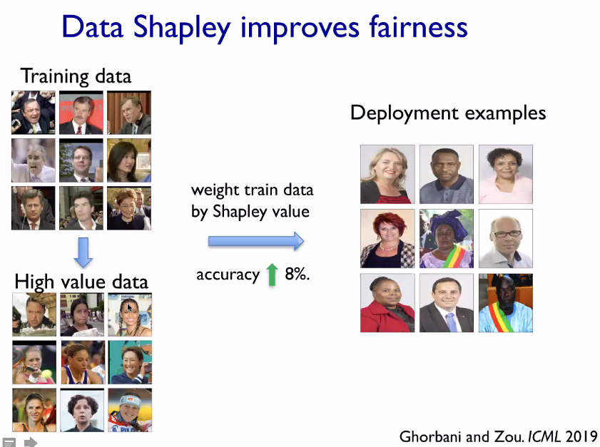

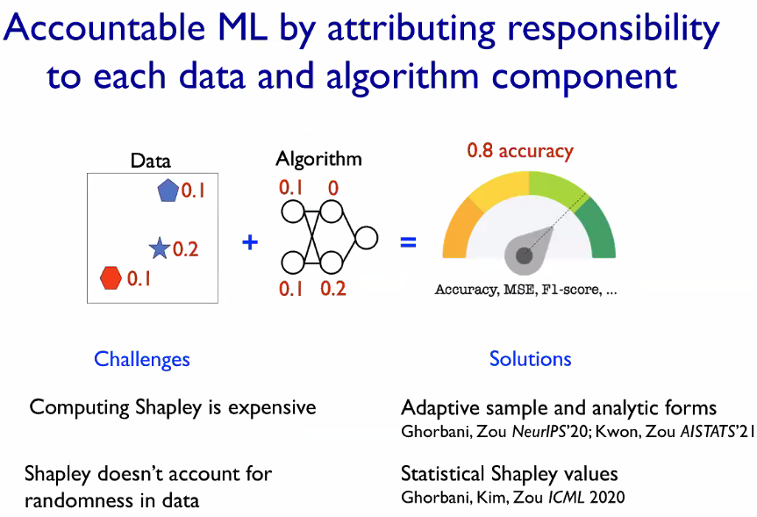

### **Challenge 3: Leveraging human with AI Data**



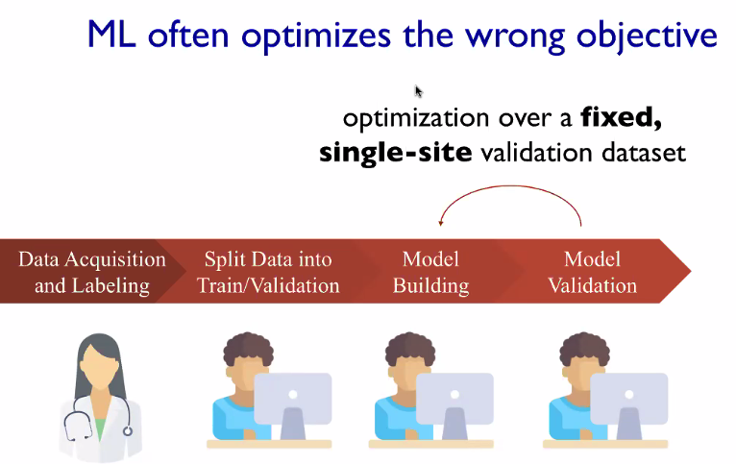

We really care about how model worksin real world: fairness, performance

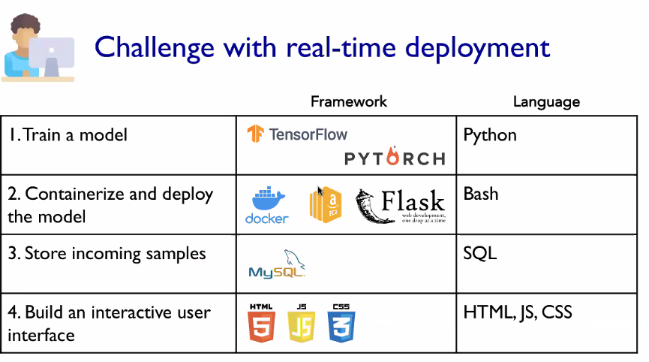

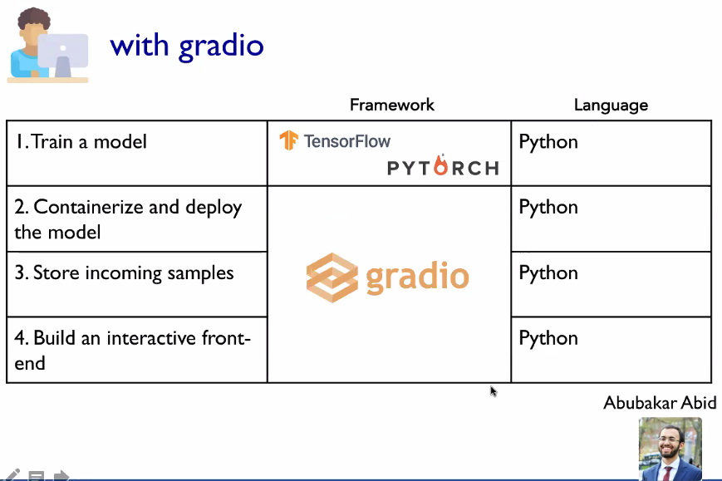

ML developers to create

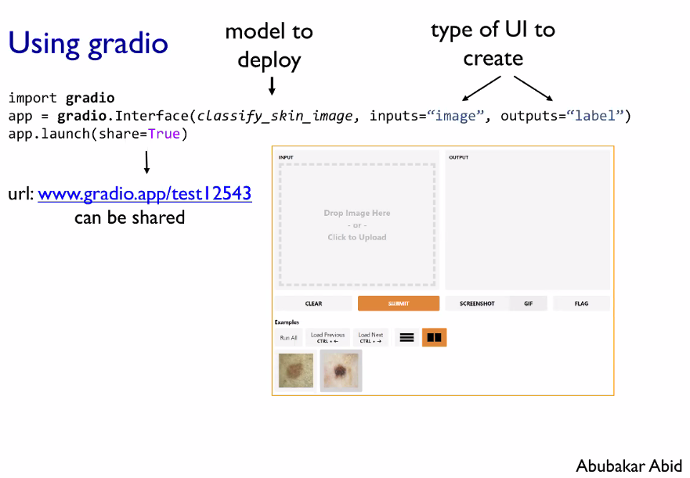

## 

## 

## Interpreting Interpretability

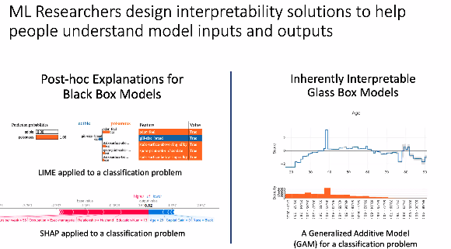

2 types: black and glass box

They want to introduce with human in the middle

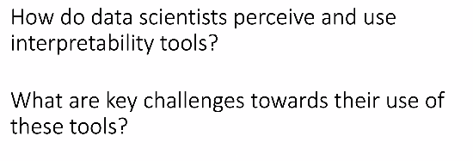

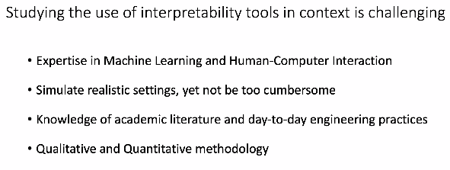

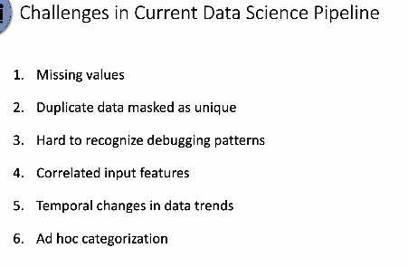

## Martin Wattenberg (Google/Harvard)

2:00-2:30

# 

# Part4: Evaluating and Debugging Deep Learning Model

## Besmira Nushi (Microsoft Research)

### 

Different Hurdles in ML deployment

Safety

Fairness

Trust- users lose trust

 Read this!!! ([link](https://www.semanticscholar.org/paper/Software-Engineering-for-Machine-Learning%3A-A-Case-Amershi-Begel/f70b2f20be241f445a61f33c4b8e76e554760340))

### Myth: Uniform Model Accuracy/Perforamcne

We overlook this because it is time-consuming, too complicated

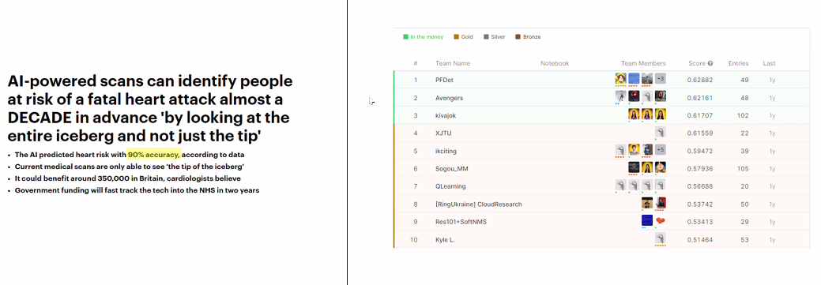

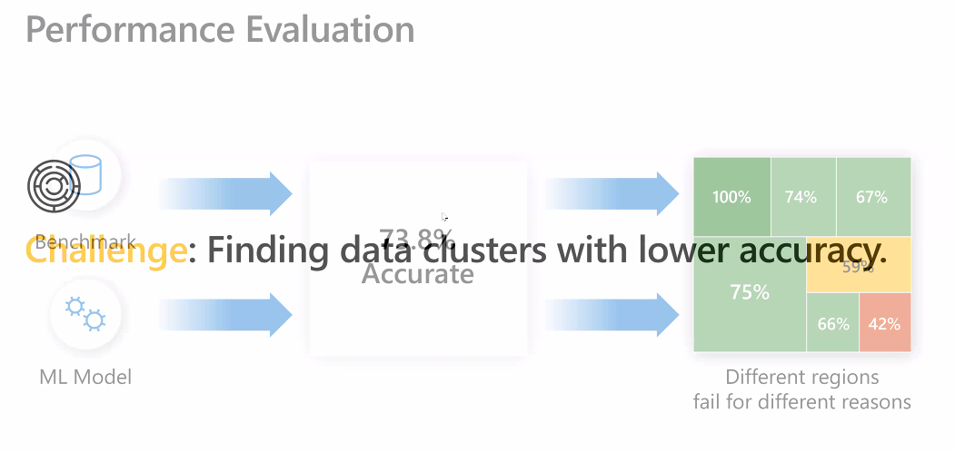

Aggregate metric (recall/precision) can hide failure modes

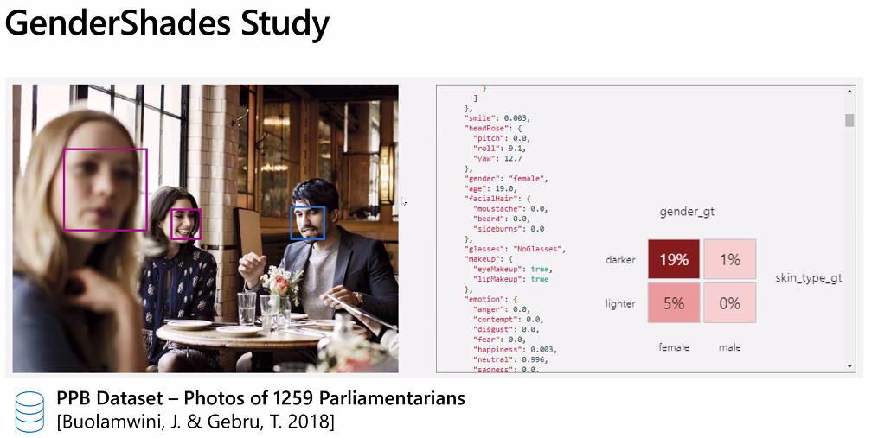

Model begins to fail more for woman in with darker skin. If dig into performance, see different by data segments.

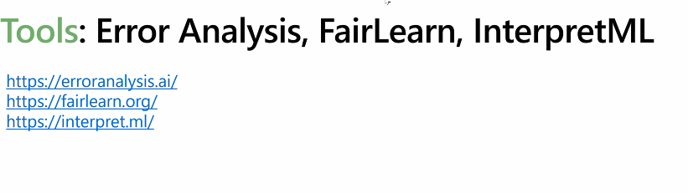

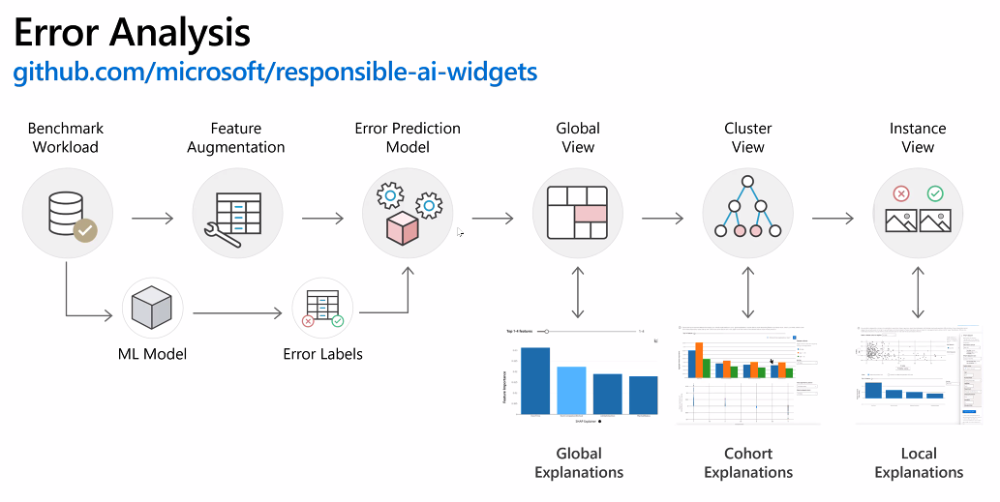

Can integrate with Jupyter notebook with widget

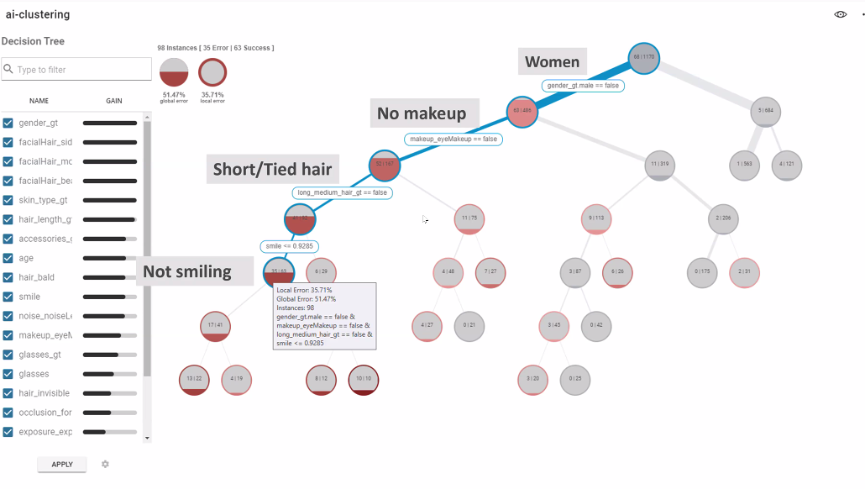

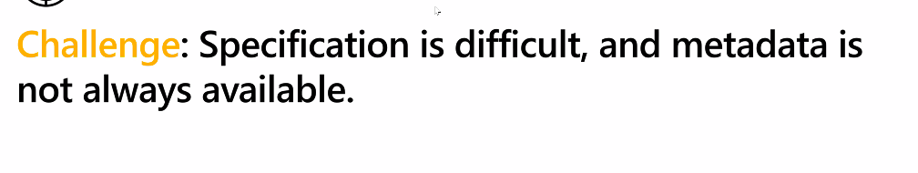

The tool requires metadata; ie lang, product category

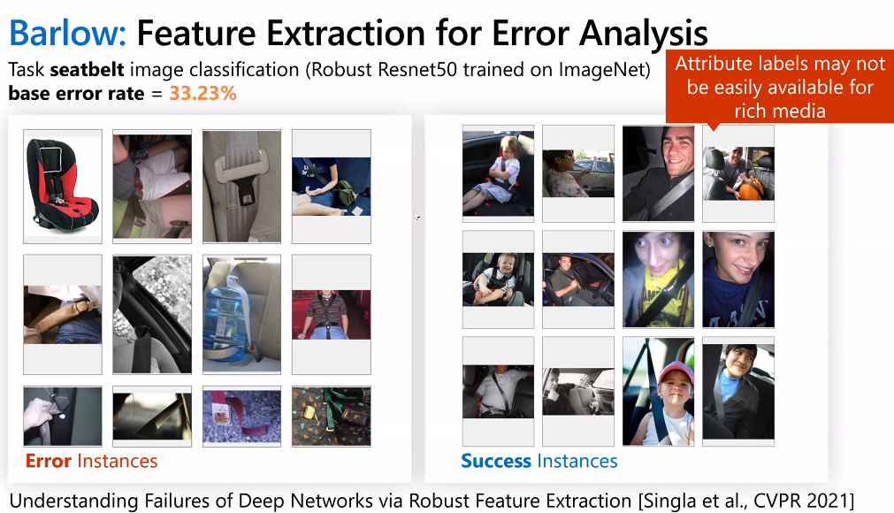

What is causing these differences between the right and fail?

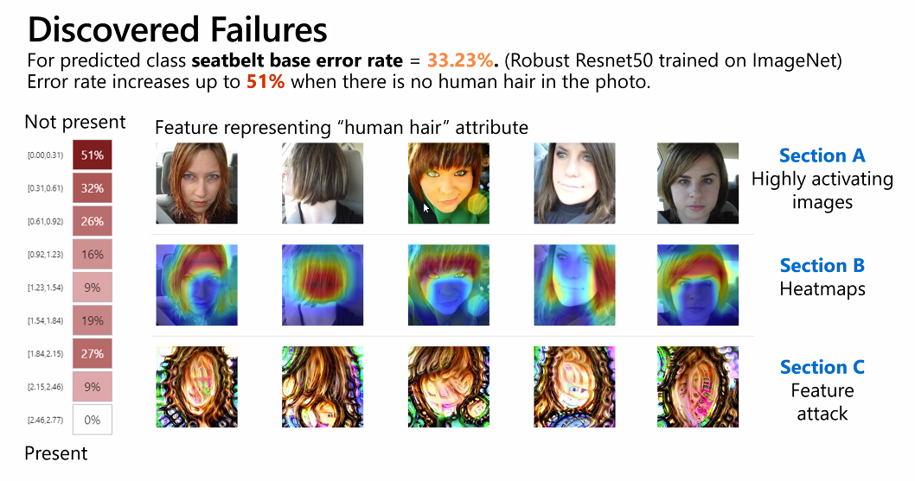

HUMAN HAIR was the key !!

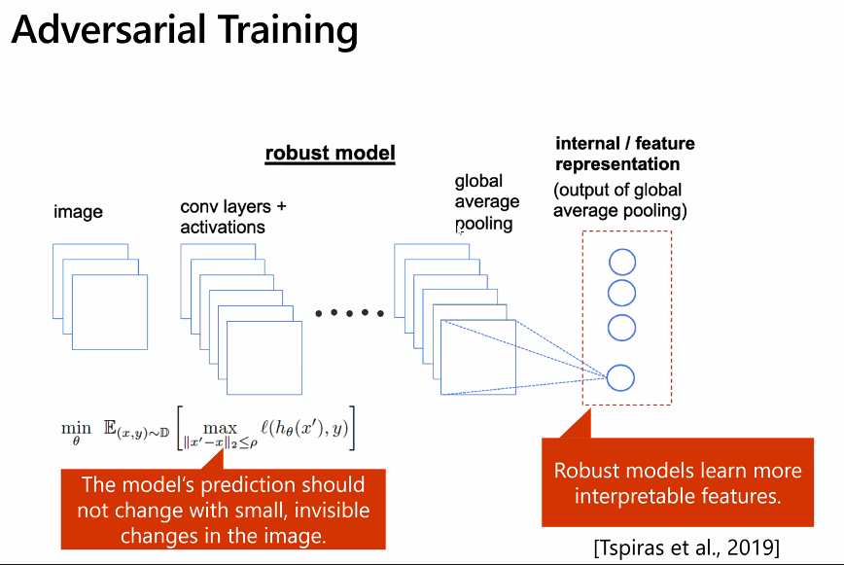

They use Adversarial Trianing to extract features

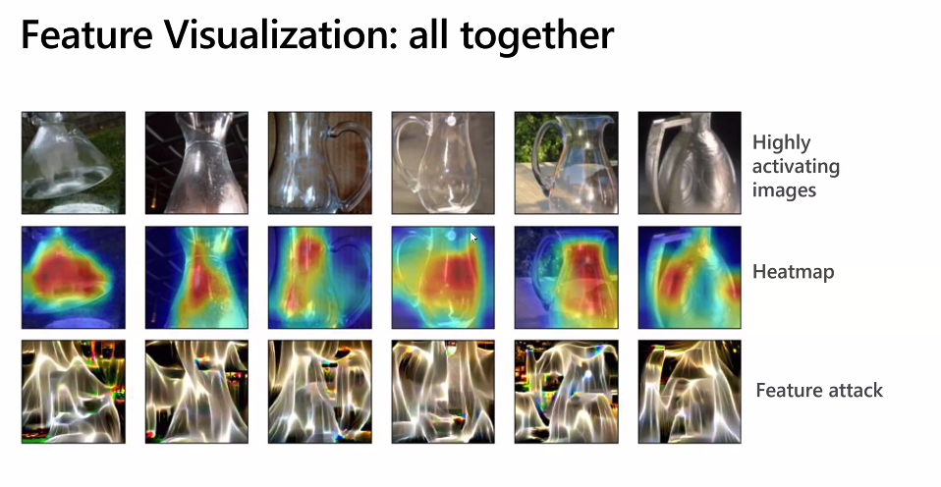

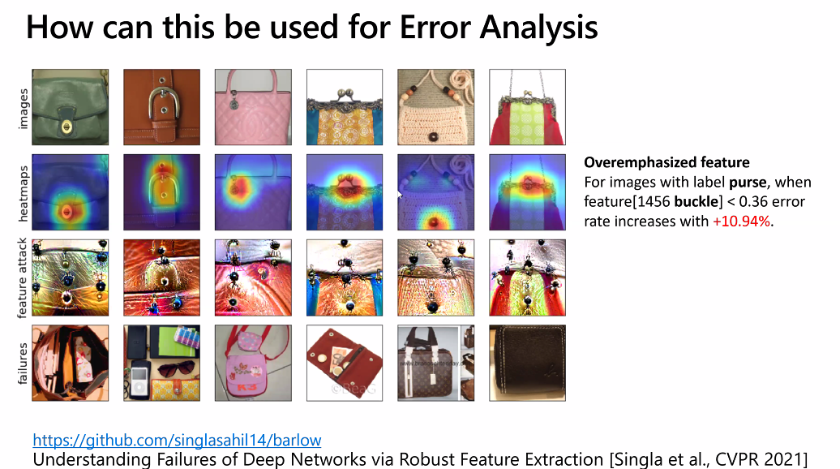

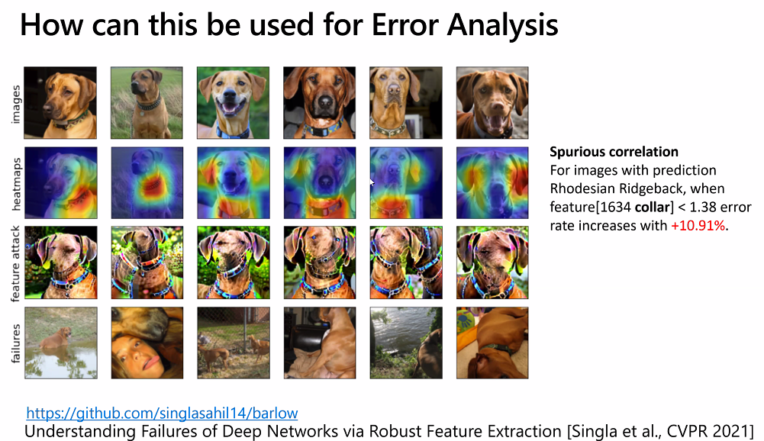

### Myth: Debugging ML model is only an issue for large models (1billion param)

Debugging is relevant for all size (k or million) parameter. No one can look at 1k parameter

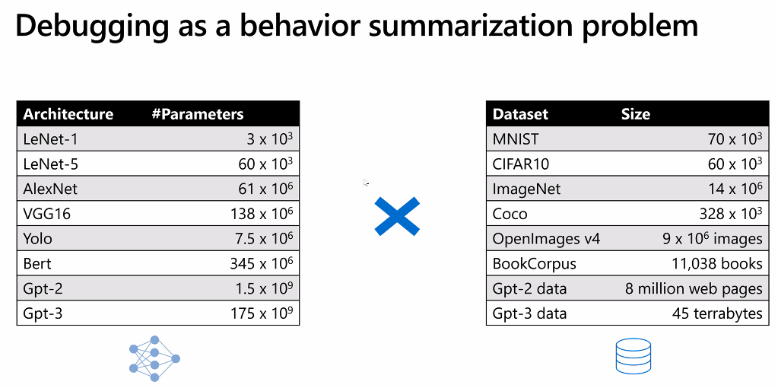

FoR 1 input:

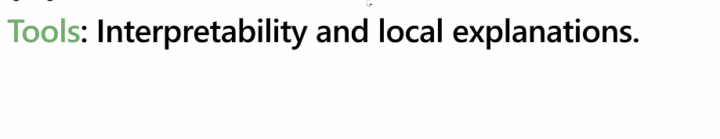

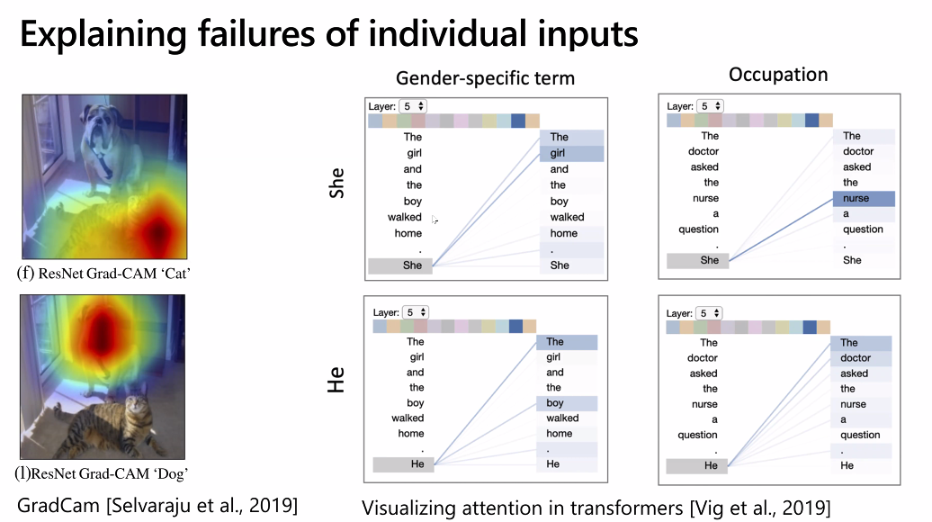

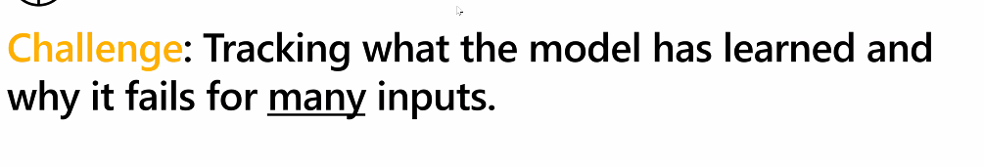

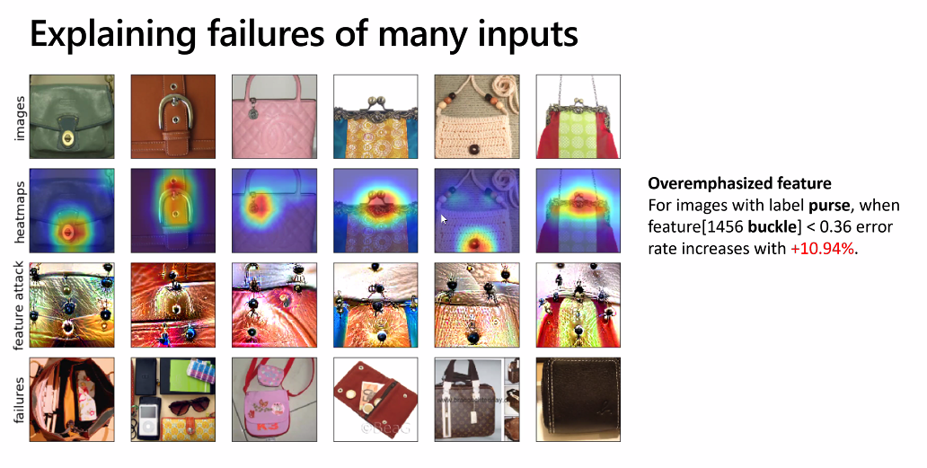

### 

### 

How to mitigate (fix?). Still need to diagnose (root cause analysis).

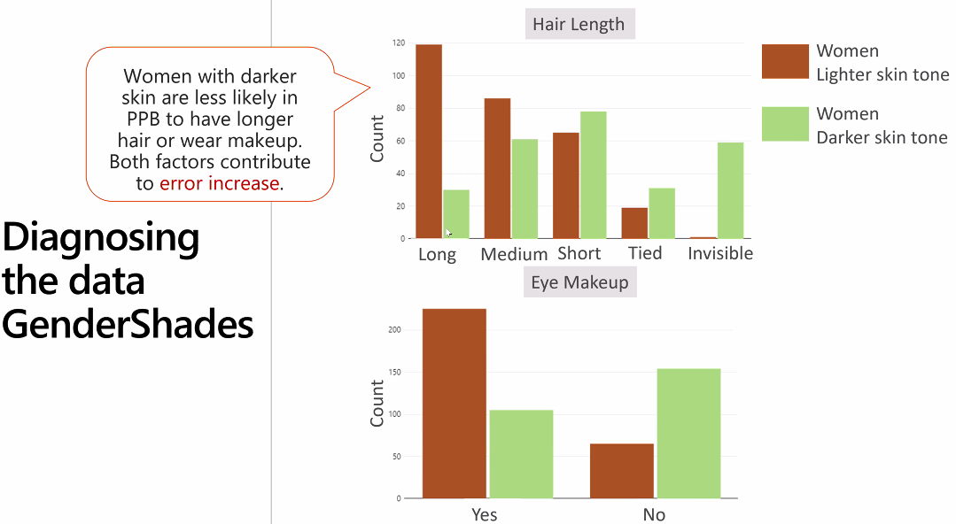

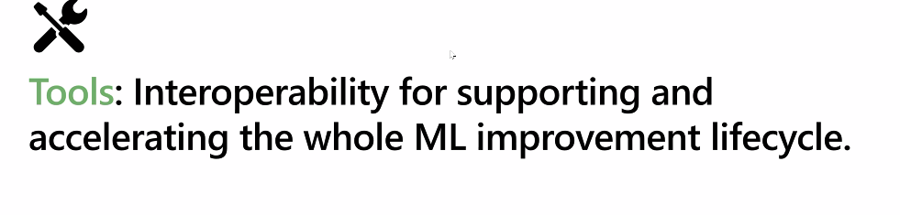

### An Integrated Tool set (WIP - months)

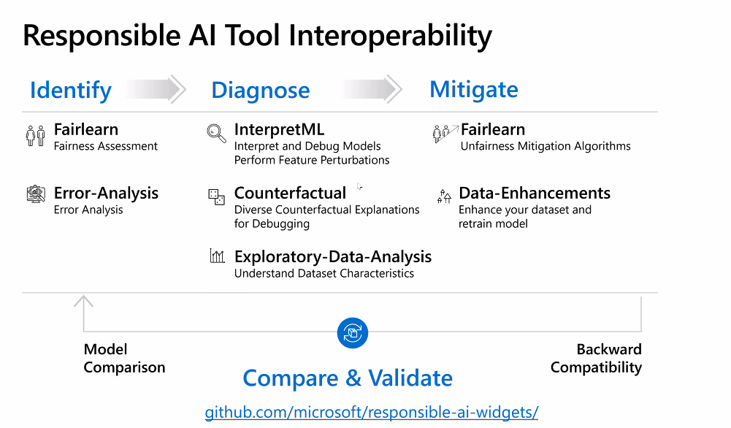

### Myth:

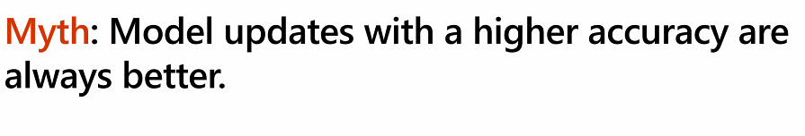

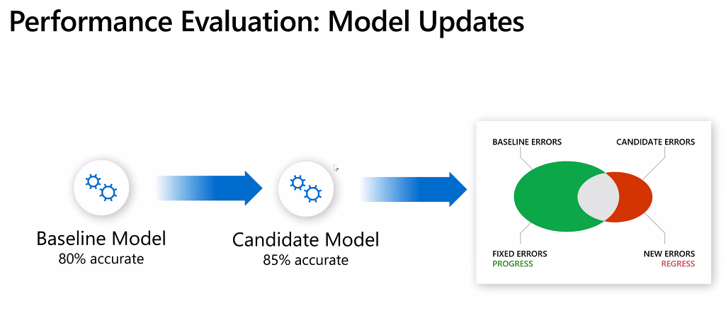

Sometimes new model can introduce from previous generation

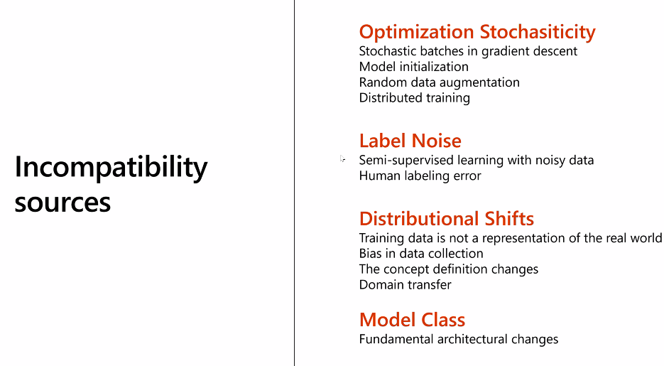

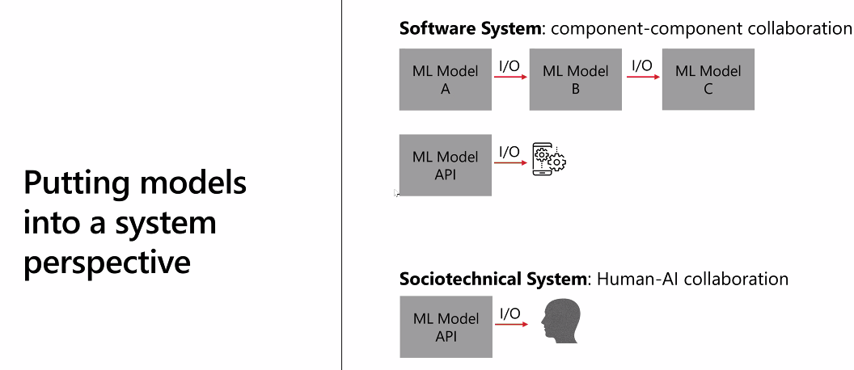

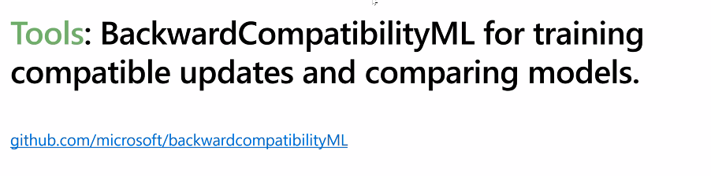

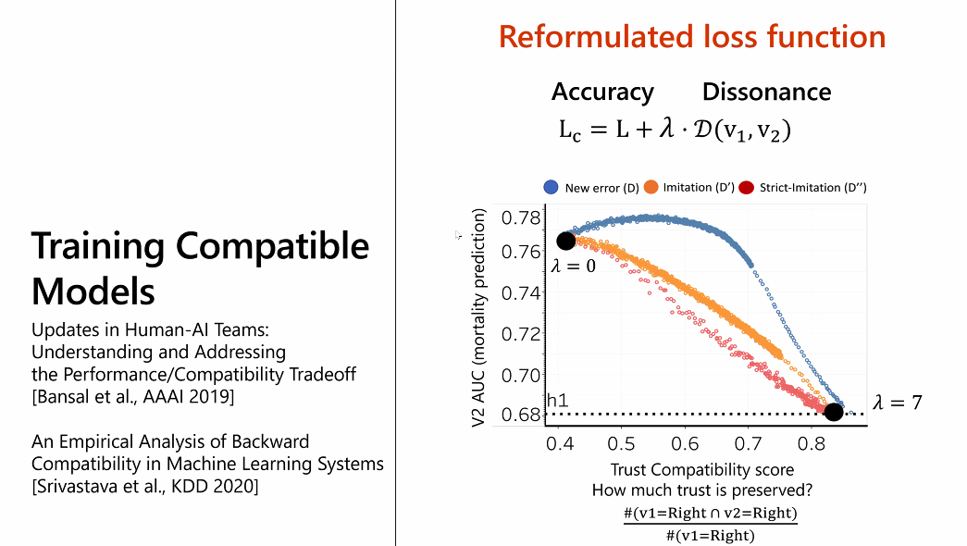

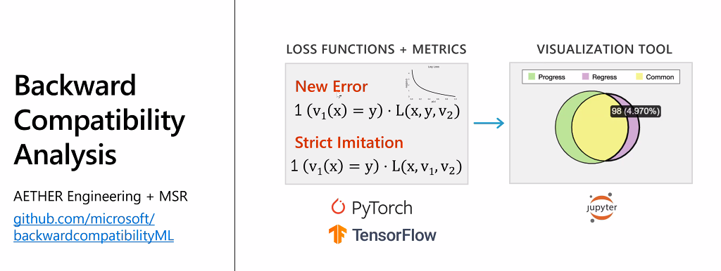

### Other aspects

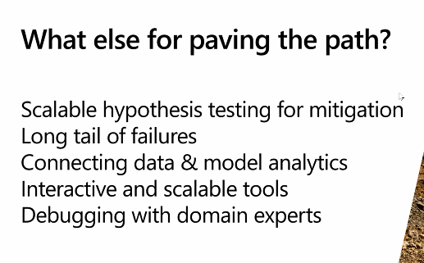

## 

## Daniel Kang: Model and Label Assertion

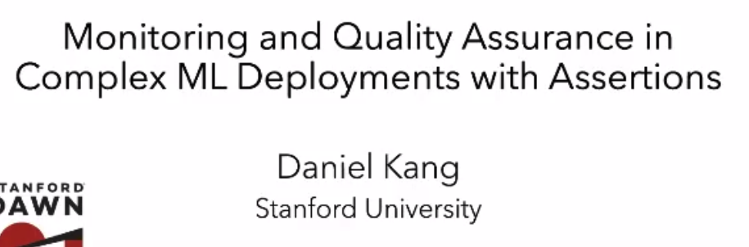

## 

## 

## 

## 

## 

## 

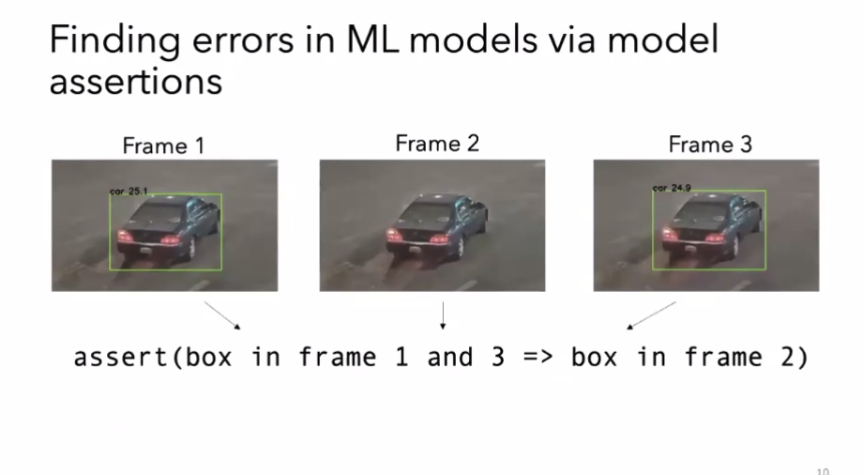

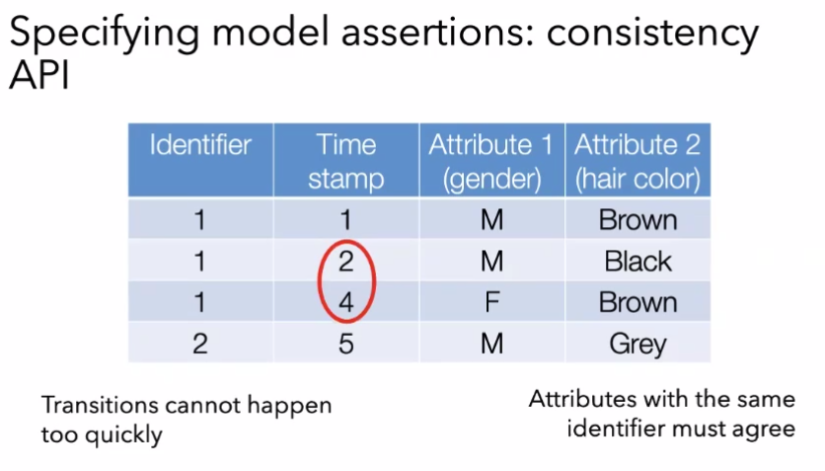

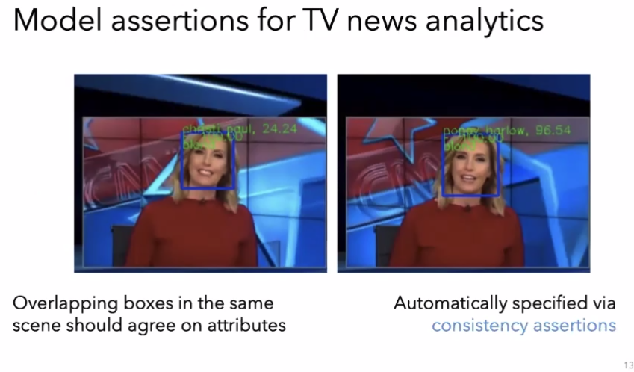

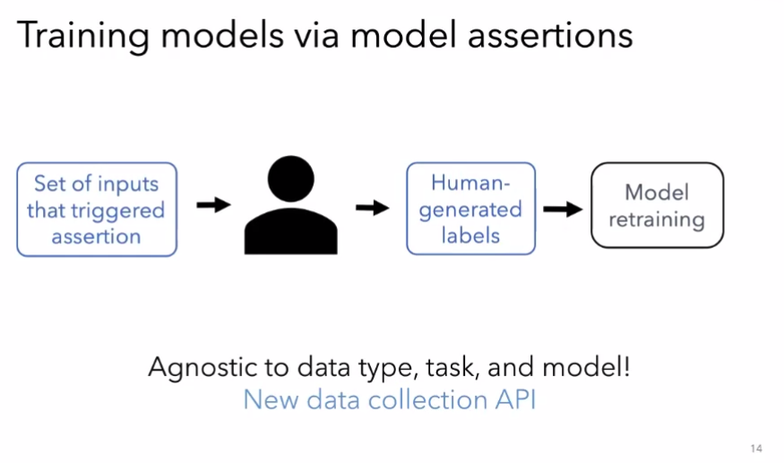

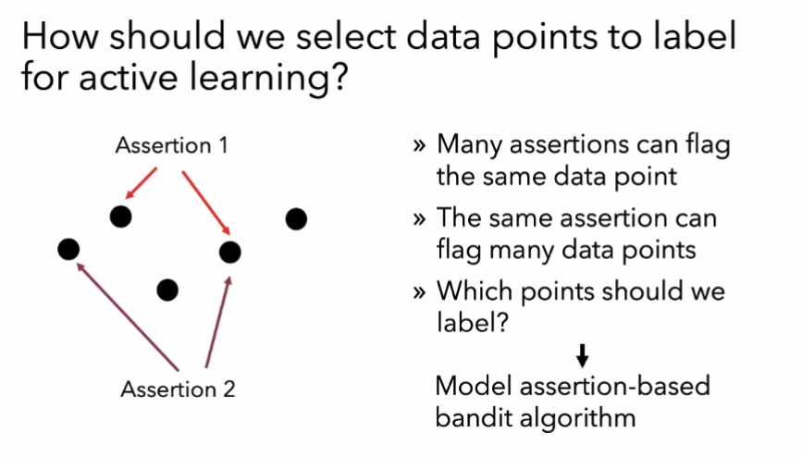

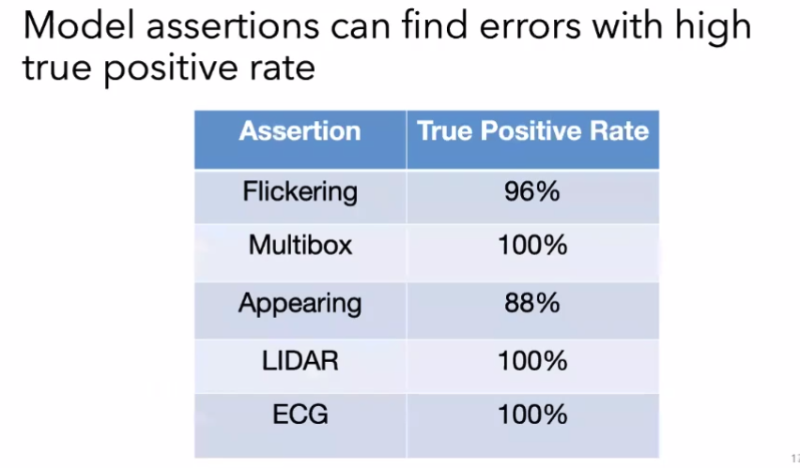

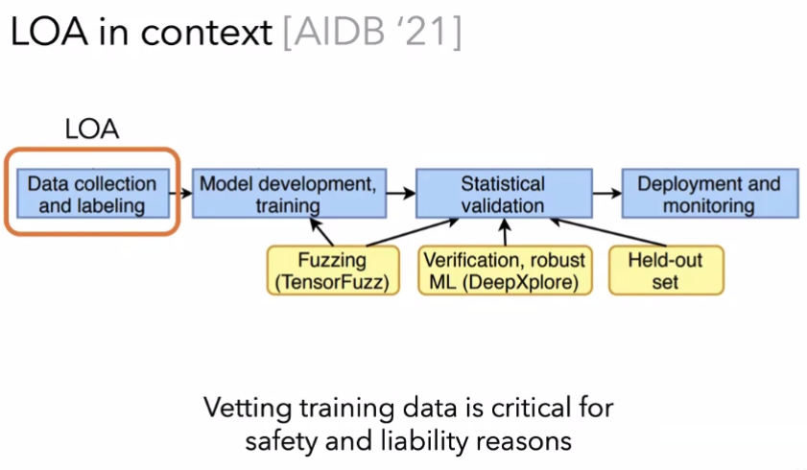

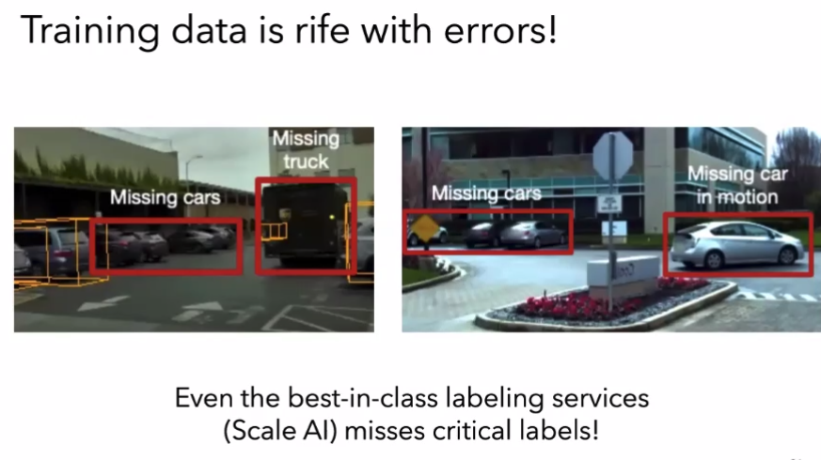

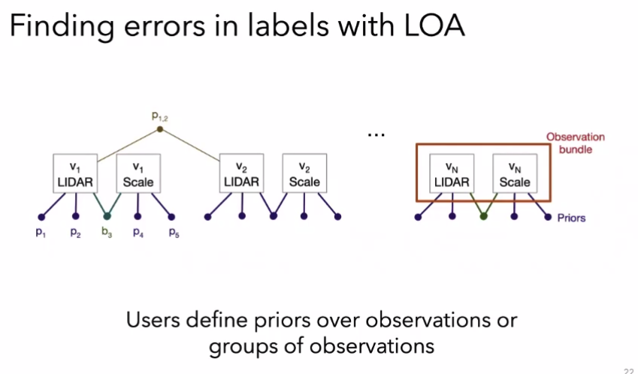

## 

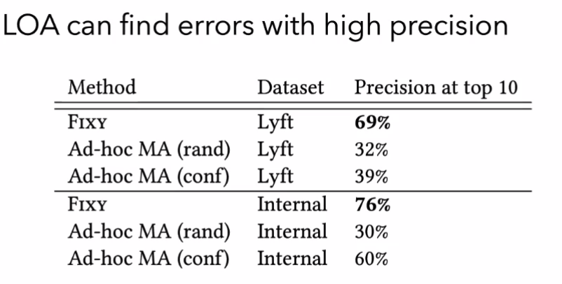

Fixy: → uses DAWN

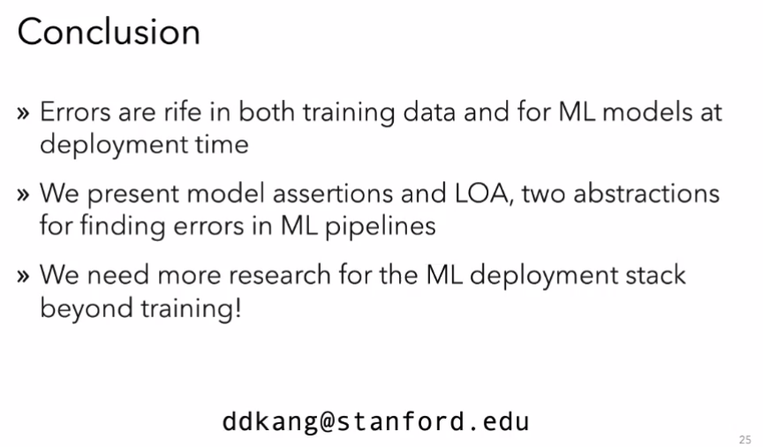

## Illusions of Network Embeddings

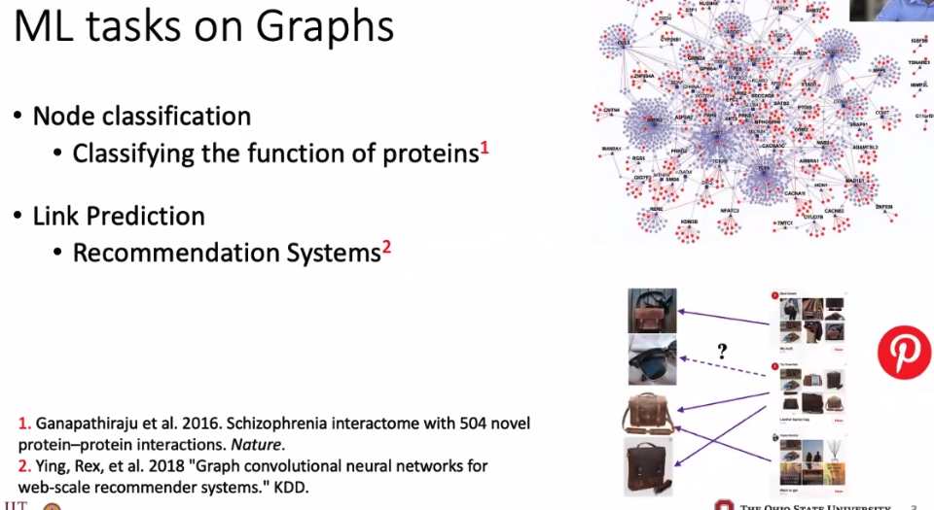

## 

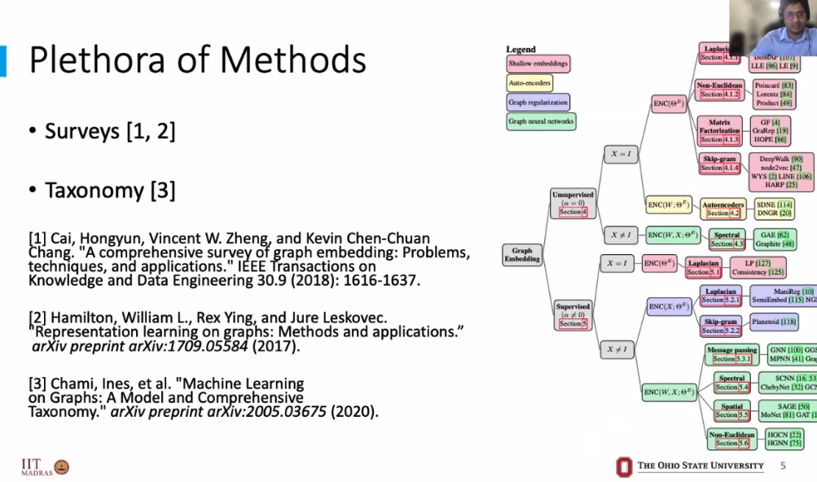

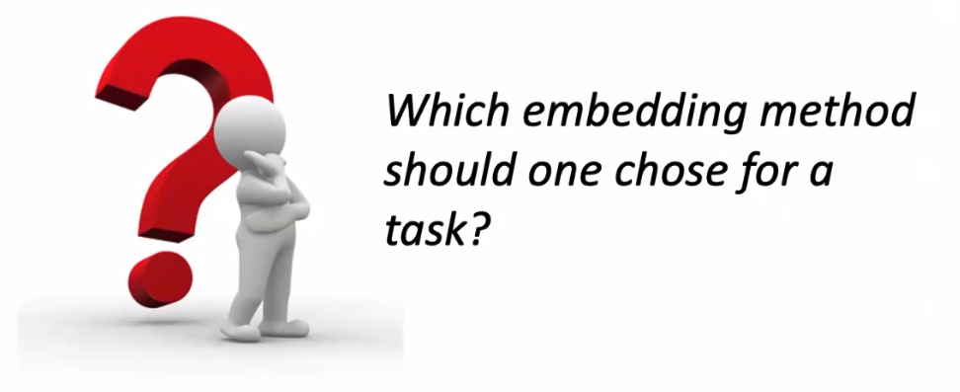

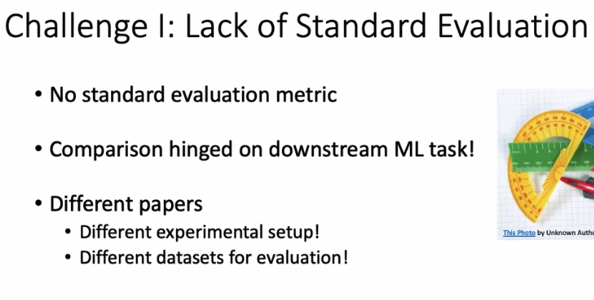

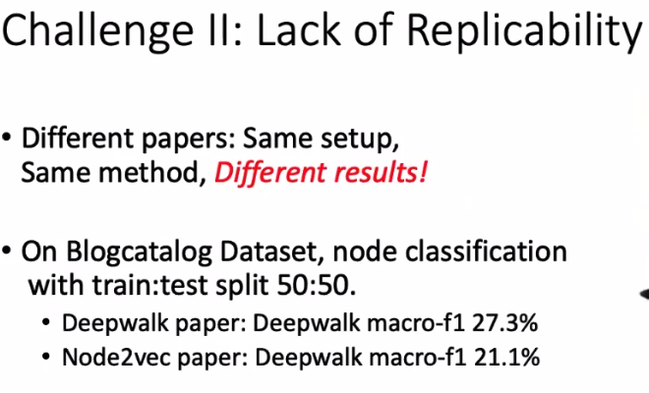

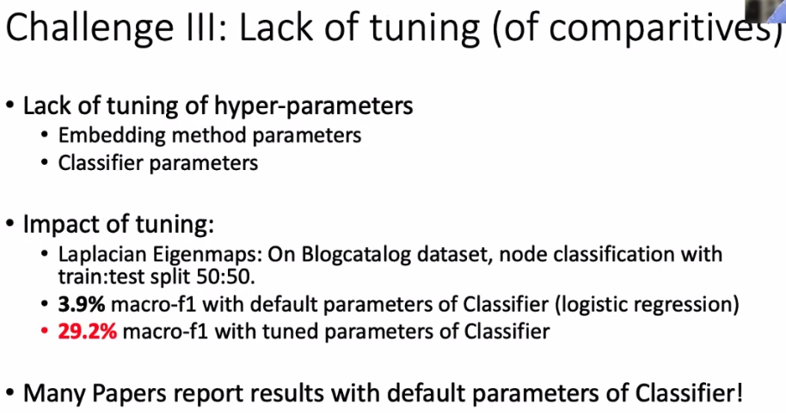

## Aleksander Madry (MIT)

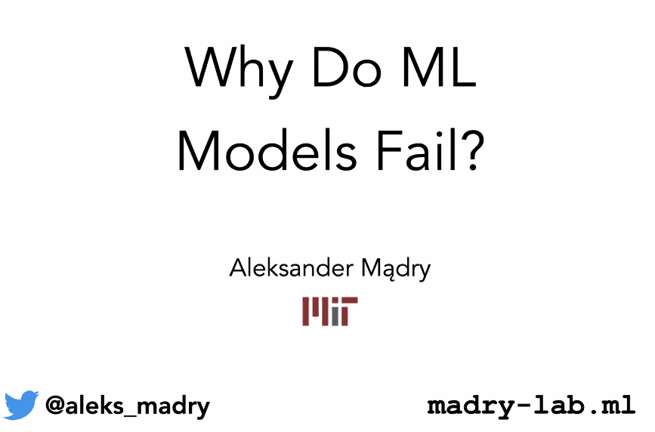

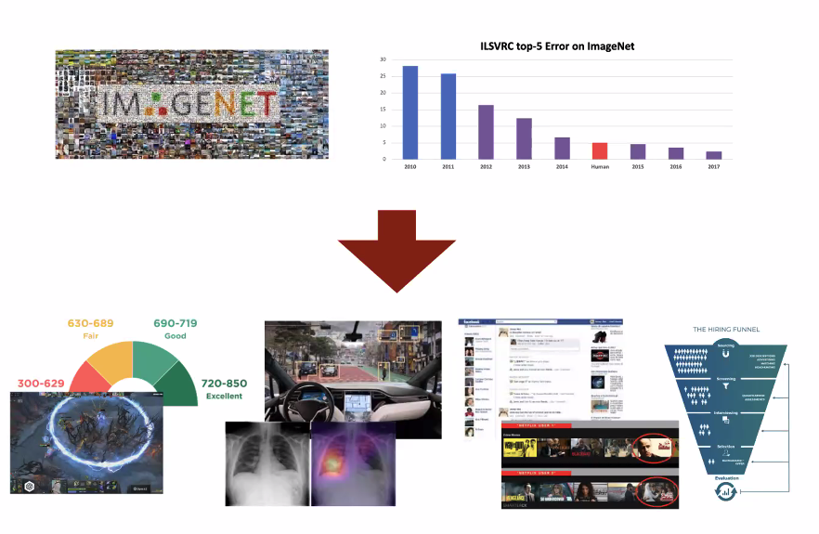

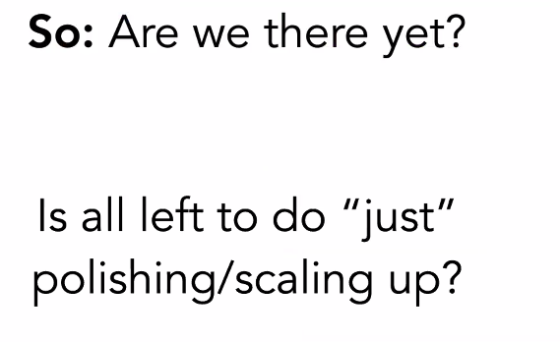



Works well on AVERAGE, but …

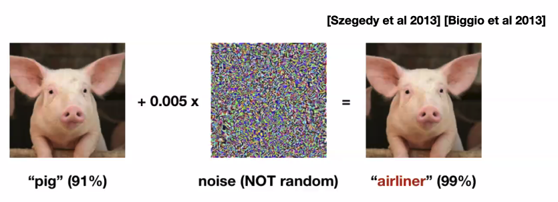

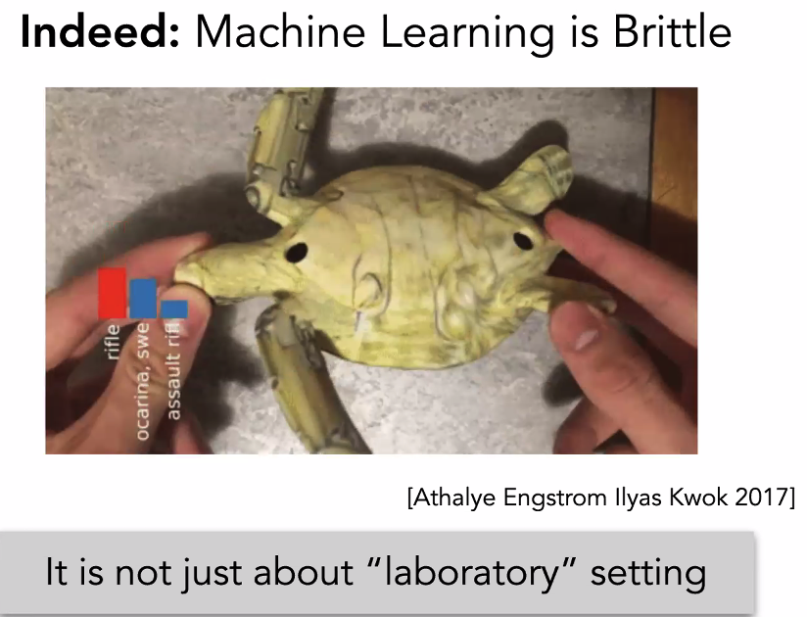

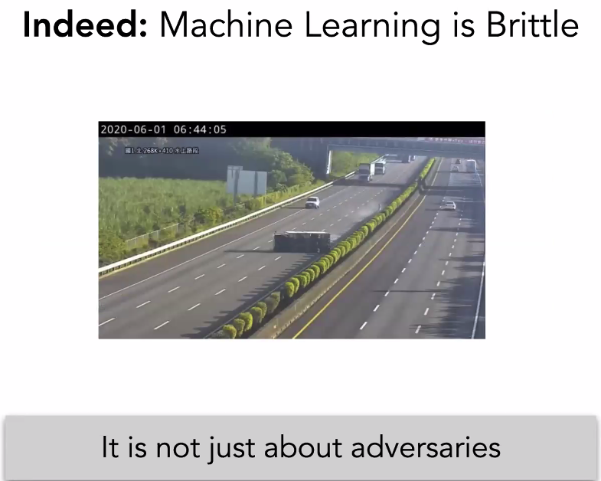



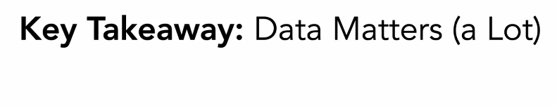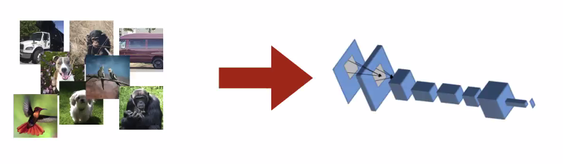

Model has been our focus; but data is why our model can become brittle. Regularization technique tries to address some of the ata

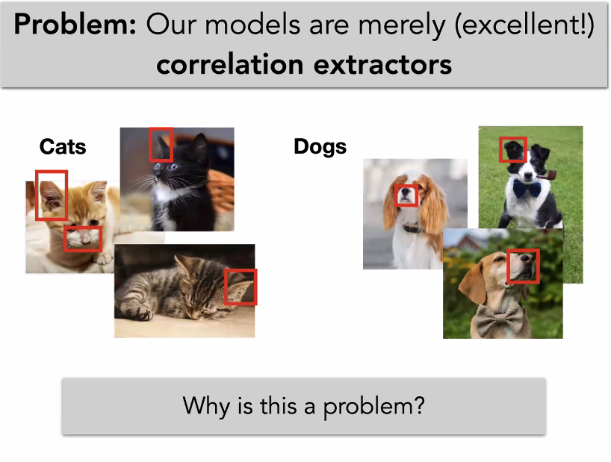

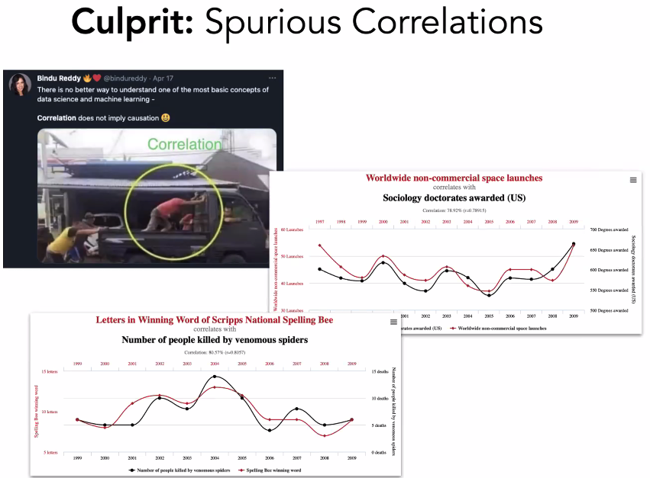

Correlation is not causation

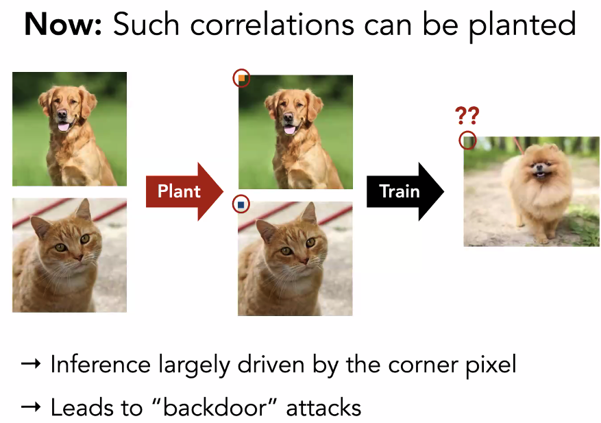

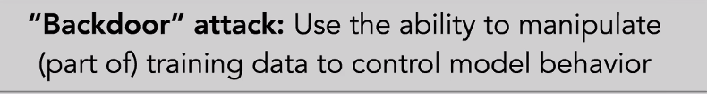

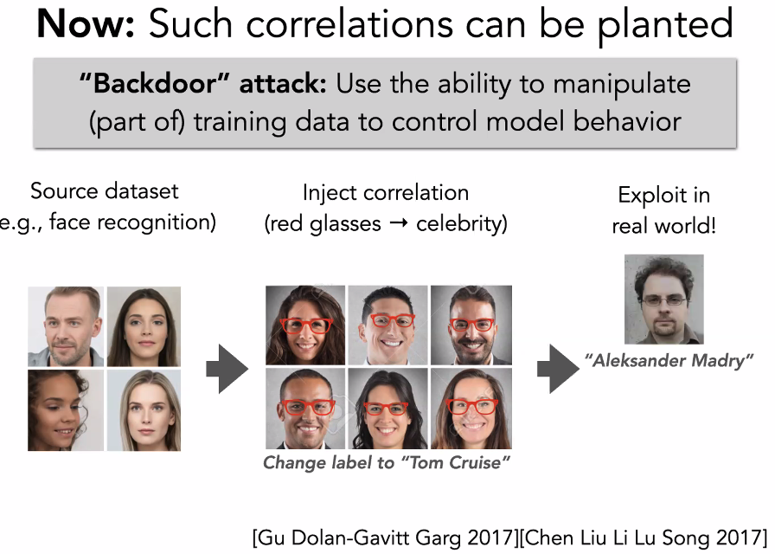

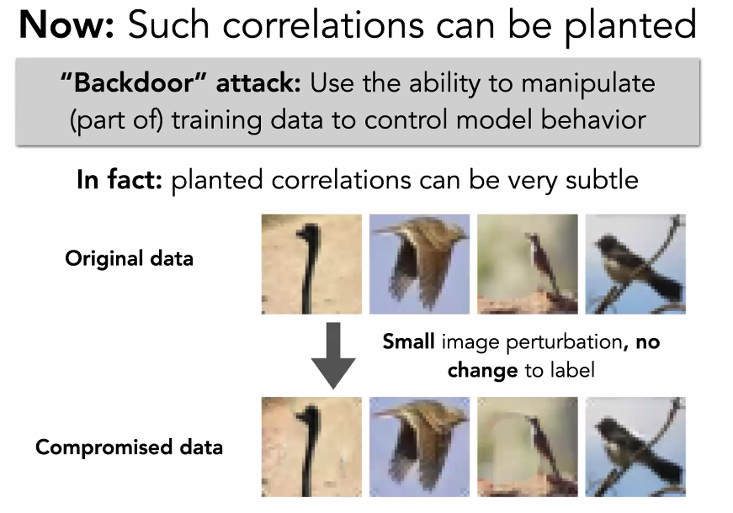

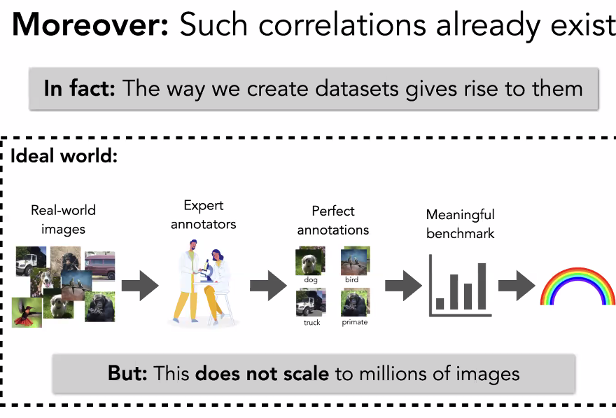

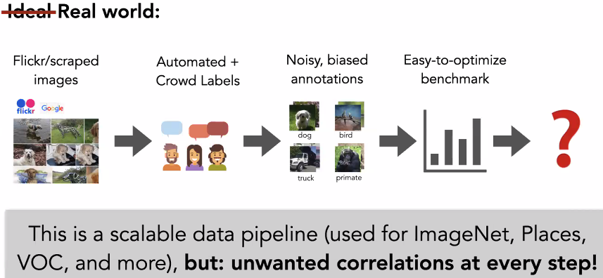



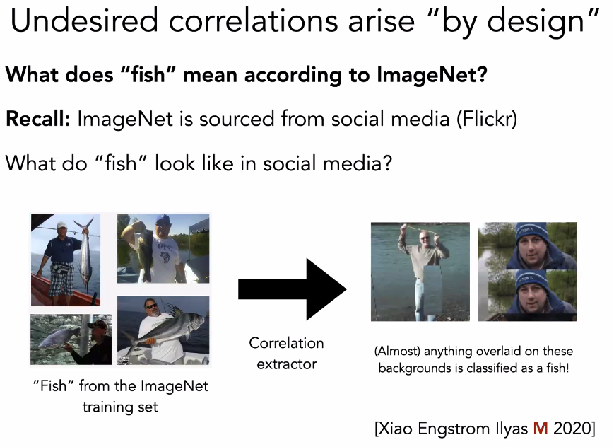

Data augmentation is not to just data set, but to also reduce correlation of unrelated features!!!

